同济大学

**《数据库技术与应用》**

**项目设计报告**

**项目设计报告题目：**

植物资料数据库“PlantDB”

**小组成员姓名 ：__**  1953776 田霈**_____________**

**班级：** 数据库技术基础

**年级：** 大三 **专业：** 生物信息学

**指导教师：** 袁科萍

**日期：** 2022 **年** 6 **月** 7 **日**

目录

一、项目设计的目的和意义 4

1. 设计目的 4

2. 项目意义 4

二、项目体系构架与主要功能描述 4

1. 体系架构 4

2. 主要功能 4

(1) 用户管理 4

(2) 词条查询 5

(3) 词条展示 5

(4) 词条评论和笔记 5

(5) 词条修改与增加 5

(6) 笔记导出 5

三．数据库设计 5

1. 数据需求分析 5

(1) 数据库架构分析 6

(2) 数据表属性 6

(3) 数据来源与处理 7

2. 概念模式设计（E-R图设计） 7

3. 逻辑模式设计（转换为关系模式和规范化处理） 9

4. 数据库实施 9

(1) 数据表创建 9

(2) 数据插入 10

(3) 存储过程 48

四．功能与界面设计 48

1. 登录界面 48

(1) 界面展示 48

(2) 功能 48

(3) 代码 48

2. 注册界面 52

(1) 界面展示 52

(2) 功能 52

(3) 代码 52

3. 用户主页界面（Home） 58

(1) 界面展示 58

(2) 功能 59

(3) 代码 59

4. 检索界面 64

(1) 界面展示 64

(2) 功能 65

(3) 代码 65

5. 物种信息查看界面 78

(1) 界面展示 78

(2) 功能 78

(3) 代码 79

6. 科信息查看界面 91

(1) 界面展示 91

(2) 功能 92

(3) 代码 92

7. 物种/科笔记编辑界面 99

(1) 界面展示 99

(2) 功能 99

(3) 代码 99

8. 物种/科评论编辑界面 104

(1) 界面展示 104

(2) 功能 105

(3) 代码 105

9. 用户权限管理界面（限定ROOT用户） 105

(1) 界面展示 105

(2) 功能 105

(3) 代码 105

五．系统测试 108

1. 登录功能测试 108

(1) 用户名不存在 108

(2) 密码错误 108

(3) 正常登录 108

2. 注册 109

(1) 用户名已存在 109

(2) 用户名格式不符合要求 109

(3) 密码不符合要求 110

(4) 两次输入的密码不一致 110

(5) 成功注册 110

10. 用户主页（Home） 111

(1) 导出笔记功能 111

(2) 增加条目功能 111

(3) 退出登录 112

11. 检索 113

(1) 中文名检索 113

(2) 学名检索 113

(3) 中文名、学名联合检索 114

(4) 检索失败 114

5. 物种信息编辑 115

6. 科信息编辑 116

7. 物种/科笔记 117

(1) 新建 117

(2) 编辑 118

(3) 删除 118

(4) 游客登录 119

8. 物种/科评论 119

(1) 新建 119

(2) 编辑 120

(3) 删除 121

(4) 游客登录 121

9. 用户权限管理界面（限定ROOT用户） 122

(1) 新增管理员 122

(2) 删除管理员 122

(3) 用户不存在 122

六．自我评述 123

七．课程学习体会与建议 123

一、项目设计的目的和意义

1. 设计目的

本项目的设计目的是为野外实习及对植物感兴趣的相关人员提供便捷的在线植物资料查询、记录工具，并实现一定程度的用户评论与展示功能。另外，用于管理权限的用户还能拥有对各类词条的编辑、增加权限，从而使得可访问数据更为丰富与准确。

2. 项目意义

使用该软件，可以让野外实习记录的整理与搜索工作更为方便快捷，且不同用户的评论与资料修正也可以为更多人传递更丰富准确的数据信息。

二、项目体系构架与主要功能描述

1. 体系架构

本项目由后端数据库与前端窗体应用软件构成。

后端数据库的搭建与管理主要通过SQL Server数据库管理系统实现，前端应用则主要通过.NET框架实现。主要开发环境为Visual Studio 2022、SQL Server Management Studio 2018。软件运行环境为Windows操作系统。

1. 主要功能
2. 用户管理

使用软件的用户可以更具自身需求选择以游客身份访问或者注册用户以使用更多样的功能，其中用户主要分为ROOT（超级管理员）、Admin（管理员，拥有管理权限）、User（普通用户）、Guest（游客）四类。注册生成的用户为普通用户，能使用评论、笔记等功能；Admin权限可由ROOT从普通用户中进行增删，在普通用户的权限基础上，Admin可以实现对词条的更新和增加；ROOT为唯一指定的超级管理员，可以使用所有功能，其中包括对Admin权限的编辑。

对于用户密码的存储，本项目采用MD5算法对密码字符串进行加密，并采用前端传输至后端进行验证加密字符串的方法对用户登录进行确认，以实现较为安全的用户登录功能。

1. 词条查询

用户可以对自己感兴趣的植物物种和所属科进行与名称和学名相关词条的模糊查询，查询结果可被更新于页面上，用户直接点击即可访问相关数据词条。

1. 词条展示

对于植物相关信息，考虑到数据的简洁与植物分类学特性（植物的科能较大程度上反映一些独特的性状），软件主要从种（Species）和科（Family）两个分类维度上进行展示。

其中，种的展示界面包含名称、学名、所属科、生长环境、分布地域、基本信息、标本图和活体图等相关信息，并提供了相关词条的网页百科链接（转到百度），方便用户更加深入地了解该物种的信息。另外，用户还可以直接跳转所属科的词条界面。

科的展示界面包含名称、学名、基本描述等信息，且数据库种属于该科的物种会显示在该页面上，用户可以直接点击跳转相关物种词条。另外，该页面也有能跳转百科网页的点击链接。

1. 词条评论和笔记

根据自己的需求和兴趣，已注册的用户可以在相关词条下进行笔记记录、评论等操作，其中，笔记仅对用户自己可见，而评论则可以对所有用户公开显示。二者均可实现增、删、改三项功能。

公开发表的评论可以逐条展示在相关词条页面的下方。

1. 词条修改与增加

拥有管理权限的用户可以实现对已有词条的编辑和新增词条的操作。词条的编辑可在词条信息展示界面通过点击编辑框选实现，而词条的新增则可以通过菜单栏中的“新增条目”实现。

1. 笔记导出

已注册用户可以导出自己做过笔记的相关条目的基本信息与笔记到Excel表格中，然后根据自己的需求进行自由编辑与保存。该功能可以通过点击菜单栏的“导出笔记”实现。

三．数据库设计

1. 数据需求分析

### (1) 数据库架构分析

本项目的数据主题为植物的物种信息、科信息以及用户信息，故主要的实体表应当为用户表（Users）、物种信息表（Species）和科信息表（Family）。另外，为了实现用户评论、笔记功能，Users分别与Species、Family相互作用形成两张关系表物种笔记表（SNotes）和科笔记表（FNotes），这两张关系表包含评论和笔记两项数据，通过isPublic（是否公开）区分。

### (2) 数据表属性

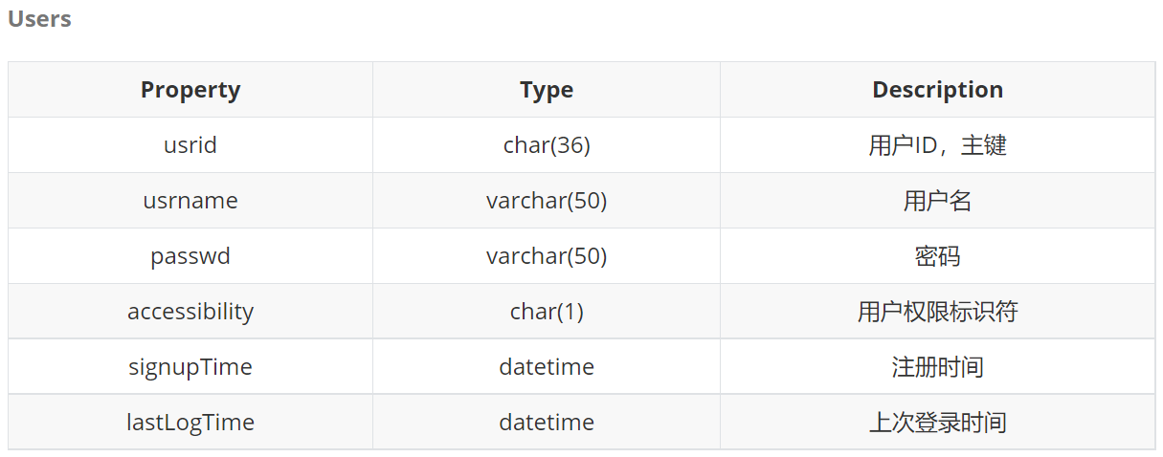

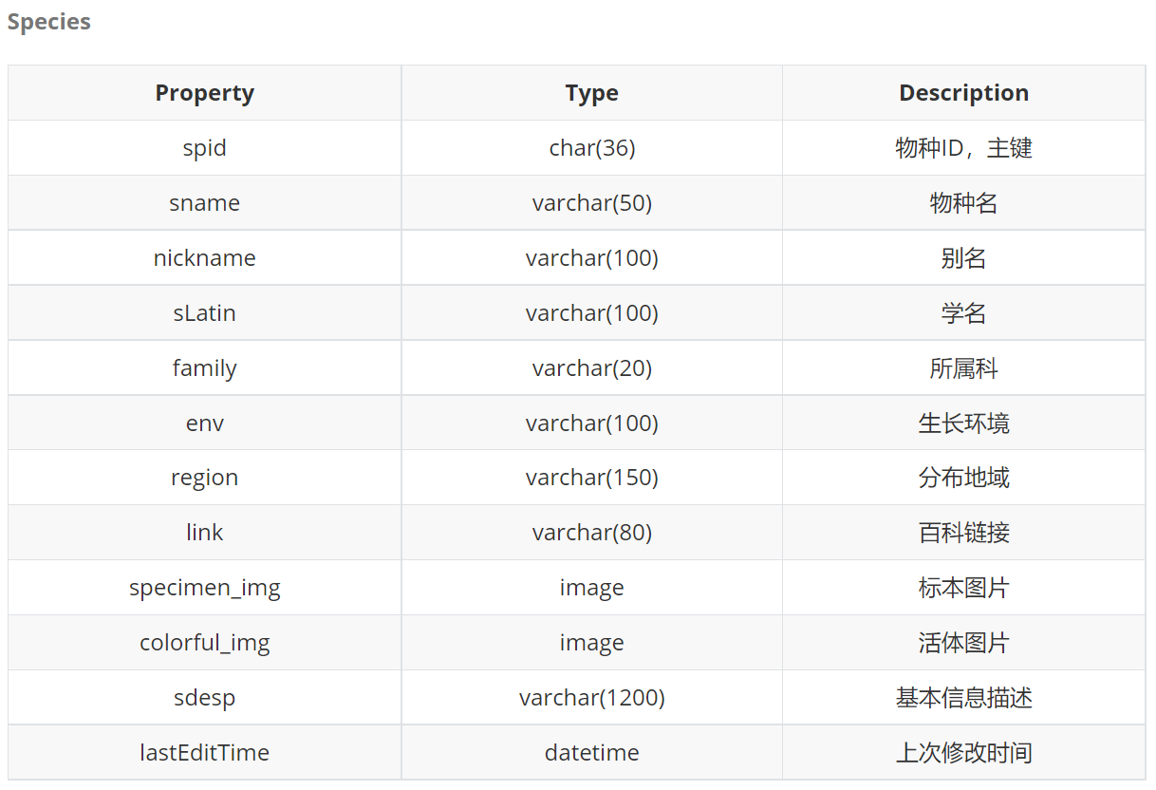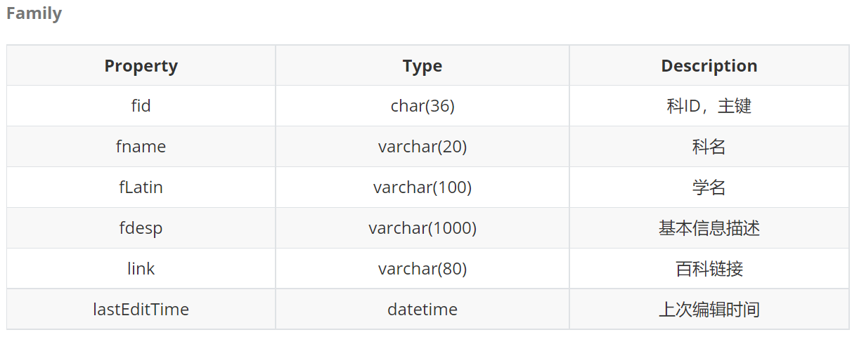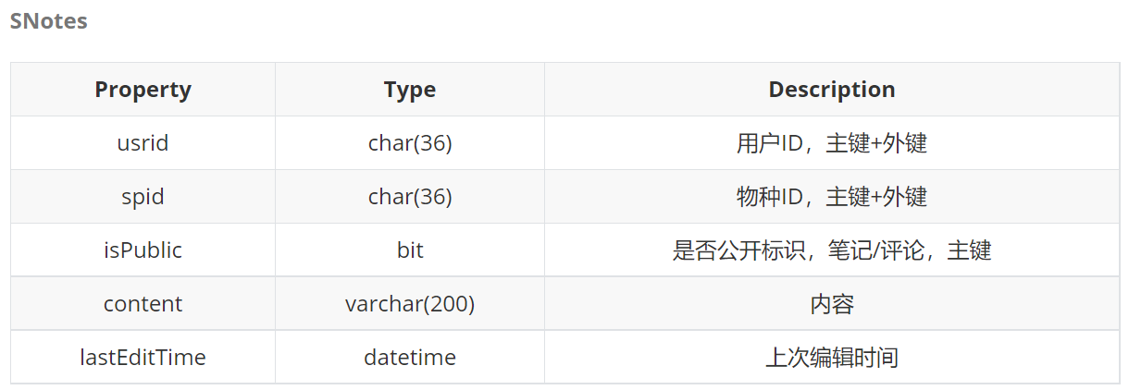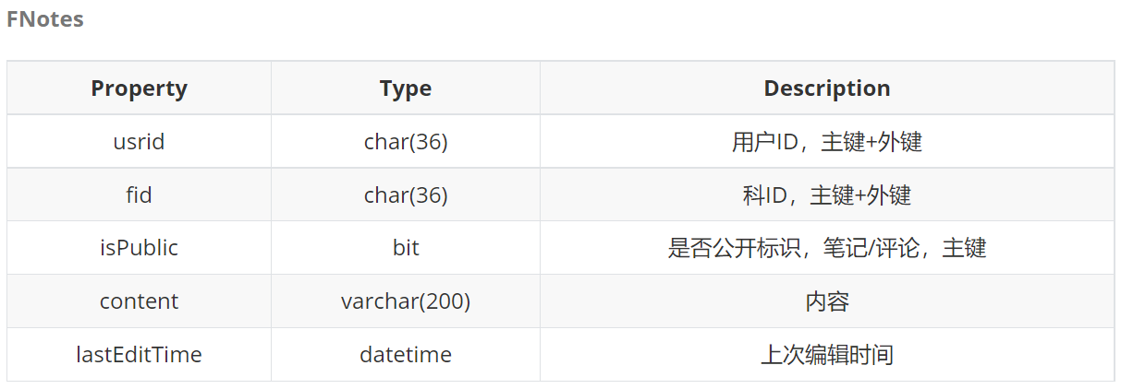

### (3) 数据来源与处理

数据的文字部分主要来源于百度百科词条，由python爬虫爬取后进行人工筛选；图片来源于来源于[中国数字植物标本馆](https://www.cvh.ac.cn/) (CVH) 数据库、百度图片，直接人工筛选了近年来拍摄的图片。

1. 概念模式设计（E-R图设计）

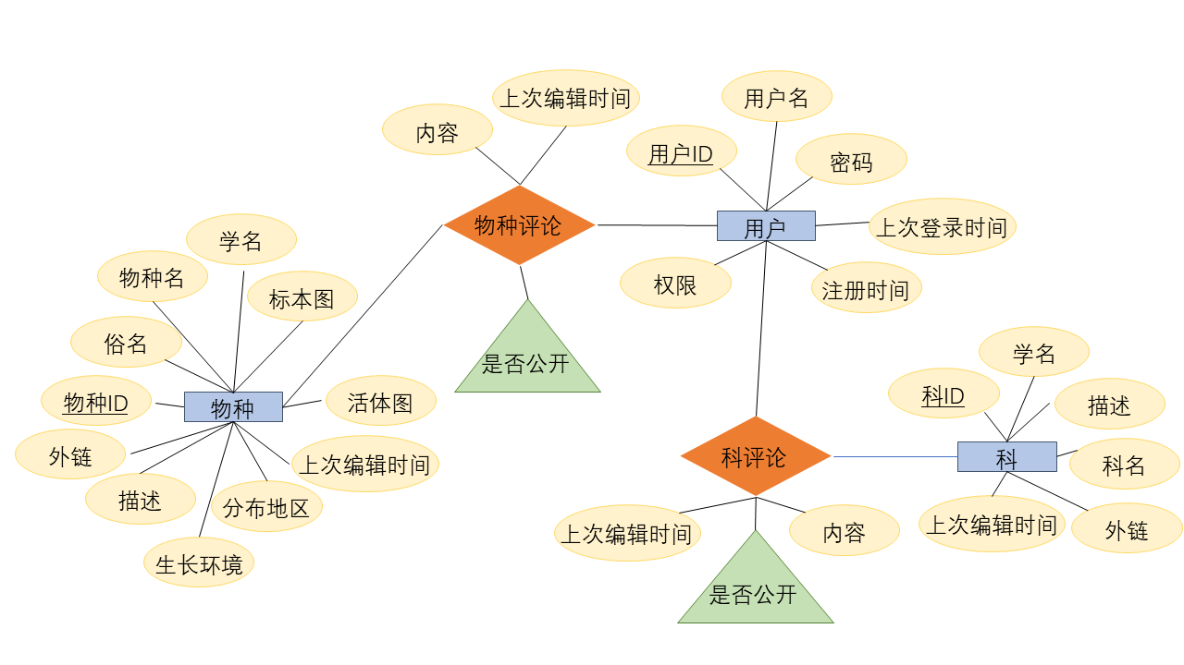

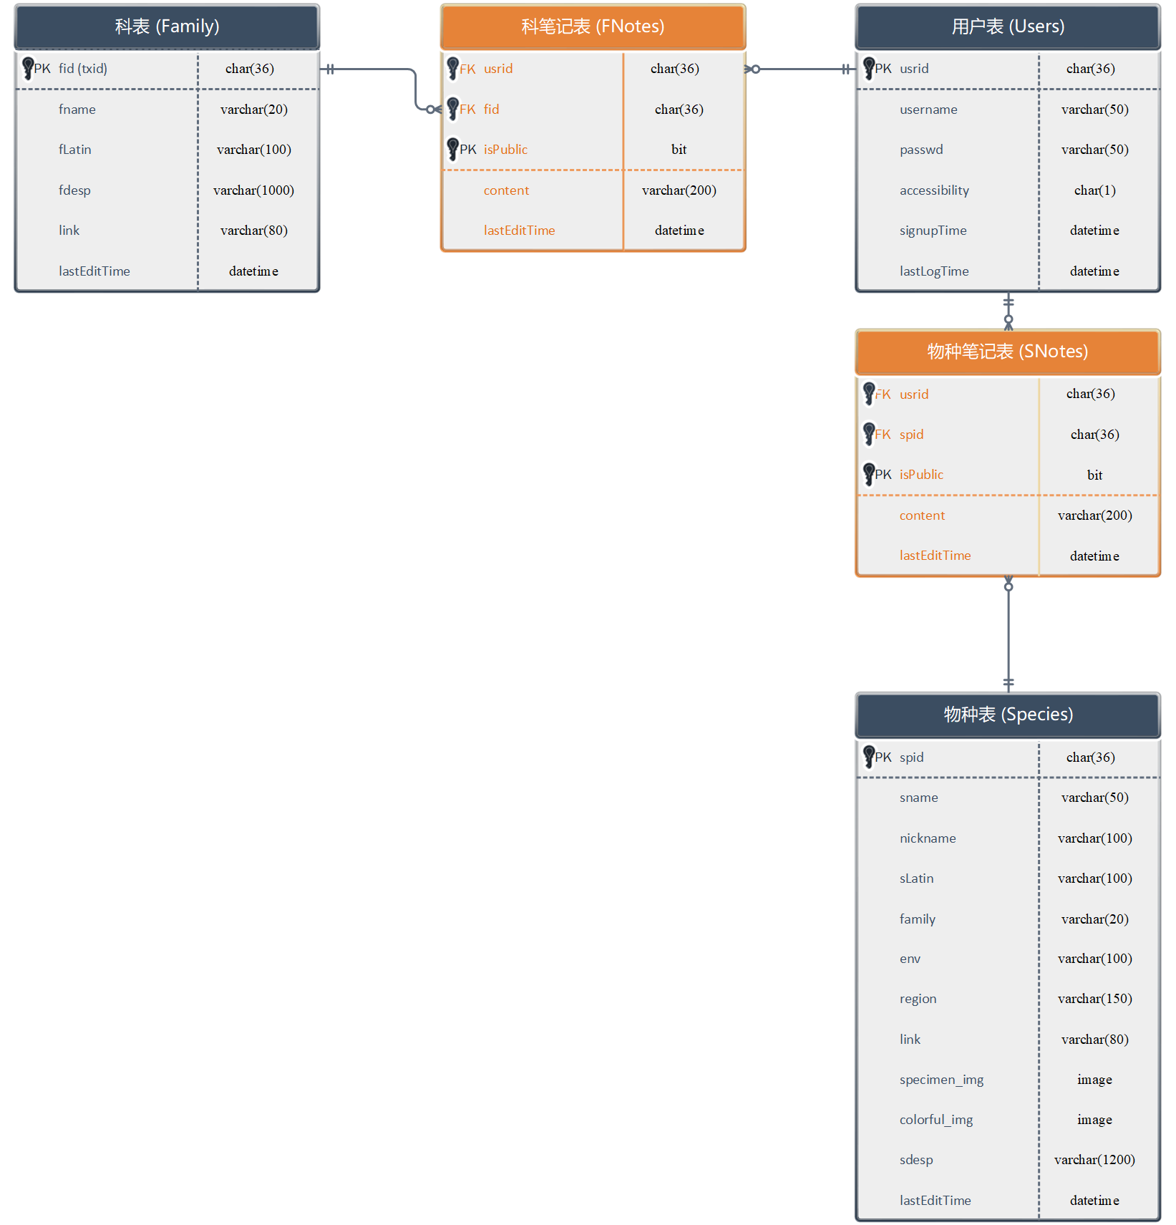

1. 逻辑模式设计（转换为关系模式和规范化处理）

**Users** (**usrid**, usrname, passwd, accessibility, signUpTime, lastLoginTime,)

**Species** (**spid**, sname, sLatin, nickname, family, env, region, sdesp, link, specimen_img, colorful_img, lastEditTime)

**Family** (**fid**, fname, fLatin, link, fdesp, lastEditTime)

**SNotes**(**usrid**, **spid**, **isPublic**, content, lastEditTime)

**FNotes**(**usrid**, **fid**, **isPublic**, content, lastEditTime)

4. 数据库实施

详见数据库SQL文件。

四．功能与界面设计

1. 登录界面

**(1) 界面展示**

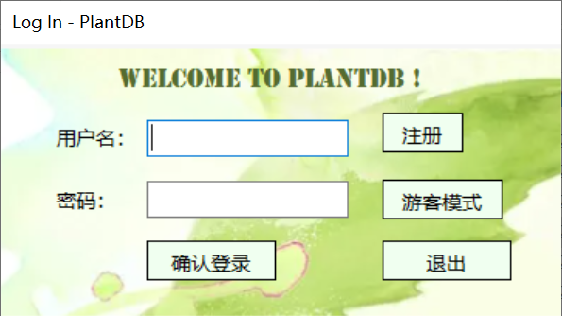

**(2) 功能**

* 已注册用户登录
* 转到注册界面
* 退出程序

**(3) 代码**

using System;

using System.Collections.Generic;

using System.ComponentModel;

using System.Data;

using System.Drawing;

using System.Linq;

using System.Text;

using System.Threading.Tasks;

using System.Windows.Forms;

using System.Data.SqlClient;

using System.Security.Cryptography;

namespace PlantDB

{

public partial class LogIn : Form

{

SqlConnection conn = new SqlConnection

("DataBase=PlantInfo; Data Source=(local); Integrated Security = True;");

public LogIn()

{

InitializeComponent();

this.Show();

this.usrBox.Focus();

}

private String toHash(String passwd) {

byte[] source = ASCIIEncoding.ASCII.GetBytes(passwd);

byte[] hash = new MD5CryptoServiceProvider().ComputeHash(source);

String output = "";

for (int i = 0; i < hash.Length; i++)

output += hash[i].ToString("X2");

return output;

}

private void tosignup_Click(object sender, EventArgs e)

{

Form signup_page = new SignUp();

this.Close();

}

private void guest_Click(object sender, EventArgs e)

{

Form guestHome = new Home("Guest", "Guest");

this.Close();

MessageBox.Show("欢迎，游客！");

}

private void exit_Click(object sender, EventArgs e)

{

Application.Exit();

}

private void confirm_Click(object sender, EventArgs e)

{

if (check_pass()) {

update_loginTime();

this.Close();

}

}

private void update_loginTime() {

String usrname = this.usrBox.Text.Trim();

String passHash = toHash(this.passwdBox.Text.Trim());

String sql = "EXEC update_loginTime '" + usrname + "', '" + passHash + "';";

SqlCommand cmd = new SqlCommand(sql, conn);

conn.Open();

cmd.ExecuteNonQuery();

conn.Close();

}

private bool check_pass() {

String usr_input = this.usrBox.Text.Trim();

String sql = "SELECT usrname FROM Users WHERE usrname = '" + usr_input + "';";

conn.Open();

SqlCommand cmd = new SqlCommand(sql, conn);

SqlDataReader dr = cmd.ExecuteReader();

if (dr.HasRows)

{

conn.Close();

String pswd_input = toHash(this.passwdBox.Text);

sql = "SELECT usrname, passwd, accessibility FROM Users " +

"WHERE usrname = '" + usr_input + "' AND passwd = '" + pswd_input + "';";

conn.Open();

cmd = new SqlCommand(sql, conn);

dr = cmd.ExecuteReader();

if (dr.HasRows)

{

dr.Read();

Form home = new Home(dr[2].ToString(), dr[0].ToString());

conn.Close();

this.Visible = false;

MessageBox.Show("欢迎！" + usr_input + "!");

return true;

}

else {

conn.Close();

MessageBox.Show("密码错误！\n请重新输入");

this.passwdBox.Text = "";

return false;

}

}

else {

conn.Close();

MessageBox.Show("用户不存在！\n请重新输入 或 注册用户");

clear_boxes();

return false;

}

}

private void clear_boxes() {

this.usrBox.Text = "";

this.passwdBox.Text = "";

}

private void usrBox_KeyDown(object sender, KeyEventArgs e)

{

if (e.KeyCode == Keys.Enter)

if (this.passwdBox.Text == "")

this.passwdBox.Focus();

else

confirm_Click(sender, e);

}

private void passwdBox_KeyDown(object sender, KeyEventArgs e)

{

if (e.KeyCode == Keys.Enter)

confirm_Click(sender, e);

}

}

}

1. 注册界面

**(1) 界面展示**

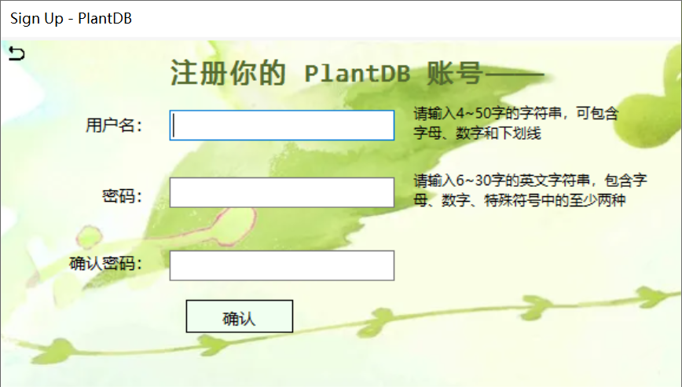

**(2) 功能**

注册新用户

**(3) 代码**

using System;

using System.Collections.Generic;

using System.ComponentModel;

using System.Data;

using System.Drawing;

using System.Linq;

using System.Text;

using System.Threading.Tasks;

using System.Windows.Forms;

using System.Security.Cryptography;

using System.Data.SqlClient;

using System.Text.RegularExpressions;

namespace PlantDB

{

public partial class SignUp : Form

{

SqlConnection conn = new SqlConnection

("DataBase=PlantInfo; Data Source=(local); Integrated Security = True;");

public SignUp()

{

InitializeComponent();

this.Show();

this.usrbox.Focus();

}

private String toHash(String passwd)

{

byte[] source = ASCIIEncoding.ASCII.GetBytes(passwd);

byte[] hash = new MD5CryptoServiceProvider().ComputeHash(source);

String output = "";

for (int i = 0; i < hash.Length; i++)

output += hash[i].ToString("X2");

return output;

}

private void button1_Click(object sender, EventArgs e)

{

if (!check_usrname())

{

this.usrbox.Text = "";

this.usrbox.Focus();

}

else {

if (!check_passwd())

{

this.passwdbox1.Text = "";

this.passwdbox2.Text = "";

this.passwdbox1.Focus();

}

else {

if (!check_repeatPasswd()) {

this.label3.Visible = true;

this.passwdbox2.Text = "";

this.passwdbox2.Focus();

return;

}

else

createAccount();

}

}

this.label3.Visible = false;

}

private void clear_inputs() {

this.usrbox.Text = "";

this.passwdbox1.Text = "";

this.passwdbox2.Text = "";

this.usrbox.Focus();

}

private bool check_usrname() {

String usrname = this.usrbox.Text.Trim();

if (usrname.Length <= 50 && usrname.Length >= 4)

{

Match match = Regex.Match(usrname, @"^[_0-9a-zA-Z]+$");

if (match.Success)

if (!is_usrname_exist(usrname))

return true;

else {

MessageBox.Show("用户名已存在！", "提示", MessageBoxButtons.OK, MessageBoxIcon.Error);

return false;

}

else

{

MessageBox.Show("用户名包含非法字符！", "提示", MessageBoxButtons.OK, MessageBoxIcon.Error);

return false;

}

}

else {

MessageBox.Show("用户名长度应为4~50！", "提示", MessageBoxButtons.OK, MessageBoxIcon.Error);

return false;

}

}

private bool is_usrname_exist(String name) {

String sql = "SELECT usrname FROM Users WHERE usrname = '" + name + "';";

SqlCommand cmd = new SqlCommand(sql, conn);

conn.Open();

SqlDataReader dr = cmd.ExecuteReader();

if (dr.HasRows)

{

conn.Close();

return true;

}

else {

conn.Close();

return false;

}

}

private bool check_passwd() {

String passwd = this.passwdbox1.Text;

if (passwd.Length >= 6 && passwd.Length <= 30)

{

Match match = Regex.Match(passwd, @"^[\d\w\W]+$");

if (match.Success) {

int char_types = Convert.ToInt32(Regex.Match(passwd, @"\d").Success) +

Convert.ToInt32(Regex.Match(passwd, @"\w").Success) +

Convert.ToInt32(Regex.Match(passwd, @"\W").Success);

if (char_types >= 2)

return true;

else {

MessageBox.Show("密码应包含数字、字母、特殊符号中的至少两种！", "提示", MessageBoxButtons.OK, MessageBoxIcon.Error);

return false;

}

}

else

{

MessageBox.Show("密码含有非法字符！", "提示", MessageBoxButtons.OK, MessageBoxIcon.Error);

return false;

}

}

else {

MessageBox.Show("密码长度应为6~30！", "提示", MessageBoxButtons.OK, MessageBoxIcon.Error);

return false;

}

}

private bool check_repeatPasswd() {

String pass1 = this.passwdbox1.Text;

String pass2 = this.passwdbox2.Text;

if (pass1 == pass2)

return true;

else

return false;

}

private void createAccount() {

String usrname = this.usrbox.Text.Trim();

String pswd = this.passwdbox1.Text;

SqlConnection conn = new SqlConnection

("DataBase=PlantInfo; Data Source=(local); Integrated Security = True;");

String sql = "INSERT INTO Users(usrname, passwd) " +

"VALUES('" + usrname + "', '" + toHash(pswd) + "'); ";

SqlCommand cmd = new SqlCommand(sql, conn);

conn.Open();

cmd.ExecuteNonQuery();

conn.Close();

DialogResult re = MessageBox.Show("用户创建成功！\n是否返回登录界面？", "提示", MessageBoxButtons.YesNo, MessageBoxIcon.Question);

if (re == DialogResult.Yes)

backToLogin();

else

clear_inputs();

}

private void back_Click(object sender, EventArgs e)

{

backToLogin();

}

private void backToLogin() {

Form login = new LogIn();

this.Close();

}

private void usrbox_KeyDown(object sender, KeyEventArgs e)

{

if (e.KeyCode == Keys.Enter)

if (this.passwdbox1.Text == "")

this.passwdbox1.Focus();

else

button1_Click(sender, e);

else if (e.KeyCode == Keys.Down)

this.passwdbox1.Focus();

else;

}

private void passwdbox1_KeyDown(object sender, KeyEventArgs e)

{

if (e.KeyCode == Keys.Enter)

if (this.passwdbox2.Text == "")

this.passwdbox2.Focus();

else

button1_Click(sender, e);

else if (e.KeyCode == Keys.Up)

this.usrbox.Focus();

else if (e.KeyCode == Keys.Down)

this.passwdbox2.Focus();

else;

}

private void passwdbox2_KeyDown(object sender, KeyEventArgs e)

{

if (e.KeyCode == Keys.Enter)

button1_Click(sender, e);

else if (e.KeyCode == Keys.Up)

this.passwdbox1.Focus();

else;

}

private void passwdbox2_TextChanged(object sender, EventArgs e)

{

if (!check_repeatPasswd())

this.label3.Visible = true;

else

this.label3.Visible = false;

}

}

}

1. 用户主页界面（Home）
2. **界面展示**

游客模式：

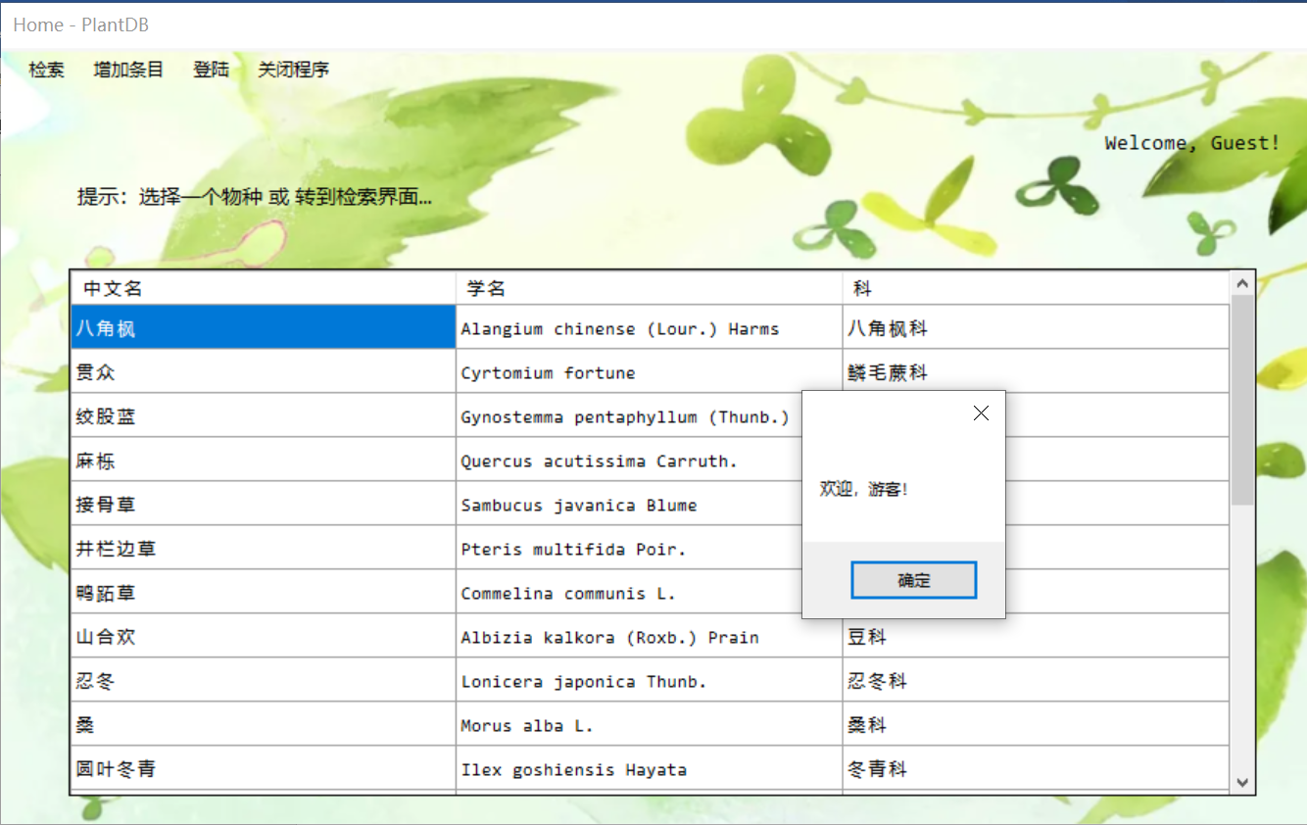

已注册用户：

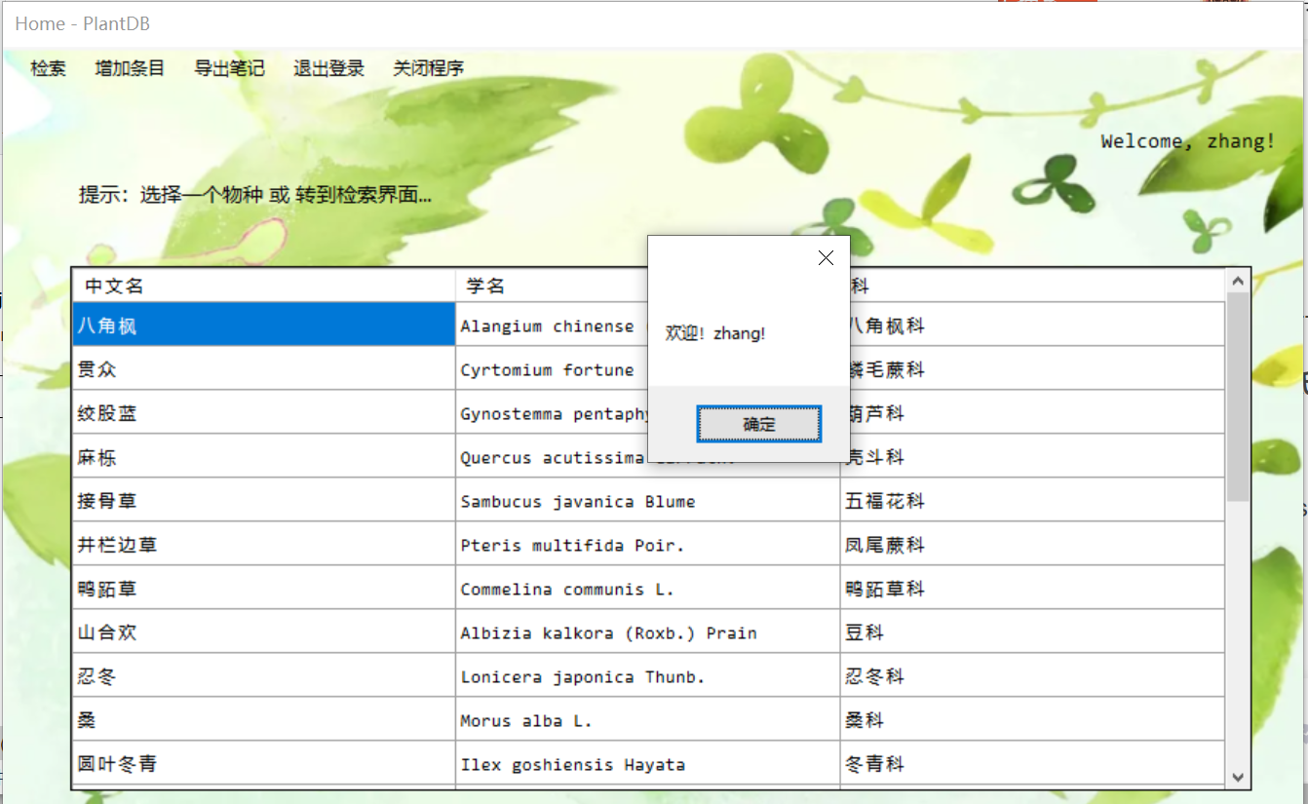

ROOT（超级管理员）：

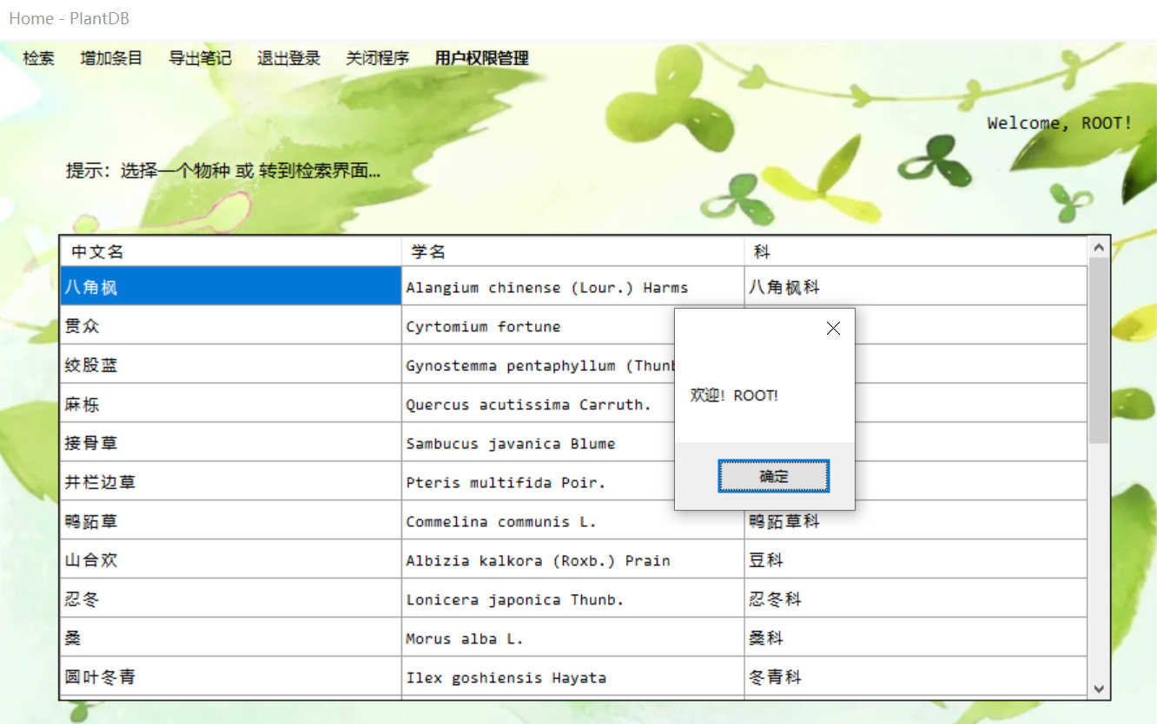

**(2) 功能**

游客模式：

* 菜单栏——检索页面跳转
* 菜单栏——增加条目
* 菜单栏——导出笔记（已登录用户）
* 菜单栏——登录（游客）
* 菜单栏——退出登录（已登录用户）
* 菜单栏——退出程序
* 菜单栏——用户权限管理（ROOT）
* 数据展示——点击条目跳转对应物种信息界面

**(3) 代码**

using System;

using System.Collections.Generic;

using System.ComponentModel;

using System.Data;

using System.Drawing;

using System.Linq;

using System.Text;

using System.Threading.Tasks;

using System.Windows.Forms;

using System.Data.SqlClient;

using Excel = Microsoft.Office.Interop.Excel;

namespace PlantDB

{

public partial class Home : Form

{

SqlConnection conn = new SqlConnection

("DataBase=PlantInfo; Data Source=(local); Integrated Security = True;");

private String usr_mode, usrname;

public Home(String mode, String usrname)

{

InitializeComponent();

usr_mode = mode;

this.usrname = usrname;

this.label1.Text += usrname + "!";

switch (mode) {

case "Guest": loadAsGuest(); break;

case "C": loadAsUser(); break;

case "A": loadAsAdmin(); break;

case "R": loadAsRoot(); break;

default: break;

}

String sql1 = "SELECT TOP 25 sname AS '中文名', sLatin AS '学名', family AS '科' FROM Species";

SqlDataAdapter adapter = new SqlDataAdapter(sql1, conn);

DataSet ds = new DataSet();

adapter.Fill(ds);

DataTable dt = ds.Tables[0].DefaultView.ToTable(false, new String[] { "中文名", "学名", "科" });

dataGridView1.DataSource = dt.DefaultView;

this.Show();

}

private void loadAsGuest() {

this.menuStrip1.Items[2].Visible = false;

this.menuStrip1.Items[4].Visible = false;

this.menuStrip1.Items[6].Visible = false;

}

private void loadAsRoot() {

this.menuStrip1.Items[3].Visible = false;

}

private void loadAsAdmin() {

this.menuStrip1.Items[3].Visible = false;

this.menuStrip1.Items[6].Visible = false;

}

private void loadAsUser() {

this.menuStrip1.Items[3].Visible = false;

this.menuStrip1.Items[6].Visible = false;

}

private void 检索ToolStripMenuItem_Click(object sender, EventArgs e)

{

Form search = new Retrieve(usr_mode, usrname);

this.Close();

}

private void 登陆ToolStripMenuItem_Click(object sender, EventArgs e)

{

Form login = new LogIn();

this.Close();

}

private void 退出登录ToolStripMenuItem_Click(object sender, EventArgs e)

{

DialogResult re = MessageBox.Show("确认要退出登录吗？", "提示", MessageBoxButtons.OKCancel, MessageBoxIcon.Question);

if (re == DialogResult.OK) {

Form login = new LogIn();

this.Close();

}

}

private void 关闭程序ToolStripMenuItem_Click(object sender, EventArgs e)

{

Application.Exit();

}

private void 用户管理ToolStripMenuItem_Click(object sender, EventArgs e)

{

Form edit = new AdminEdit(usr_mode, usrname);

this.Close();

}

private void 物种ToolStripMenuItem_Click(object sender, EventArgs e)

{

Form species;

if (usr_mode == "A" || usr_mode == "R")

{

species = new SpeciesInfo("new", usr_mode, usrname, true);

this.Close();

}

else MessageBox.Show("对不起！\n您不具有管理权限，不能进行该操作", "提示", MessageBoxButtons.OK, MessageBoxIcon.Error);

}

private void 科ToolStripMenuItem_Click(object sender, EventArgs e)

{

Form family;

if (usr_mode == "A" || usr_mode == "R")

{

family = new FamilyInfo("new", usr_mode, usrname, true);

this.Close();

}

else MessageBox.Show("对不起！\n您不具有管理权限，不能进行该操作", "提示", MessageBoxButtons.OK, MessageBoxIcon.Error);

}

private void 导出笔记ToolStripMenuItem_Click(object sender, EventArgs e)

{

}

private void 物种笔记ToolStripMenuItem_Click(object sender, EventArgs e)

{

Excel.Application app = new Excel.Application();

Excel.Workbook wb = app.Workbooks.Add();

Excel.Worksheet ws;

app.SheetsInNewWorkbook = 1;

app.Caption = "Species_Info.xlsx";

ws = wb.Worksheets[1];

ws.Cells.Item[1, 1] = "物种名";

ws.Cells.Item[1, 2] = "学名";

ws.Cells.Item[1, 3] = "科名";

ws.Cells.Item[1, 4] = "生长环境";

ws.Cells.Item[1, 5] = "分布地域";

ws.Cells.Item[1, 6] = "描述";

ws.Cells.Item[1, 7] = "笔记";

String sql = "SELECT sname, sLatin, family, env, region, sdesp, content " +

"FROM Species RIGHT JOIN SNotes ON Species.spid = SNotes.spid " +

"RIGHT JOIN Users ON Users.usrid = SNotes.usrid " +

"WHERE SNotes.isPublic = 0 AND Users.usrname ='" + usrname + "'; ";

SqlCommand cmd = new SqlCommand(sql, conn);

conn.Open();

SqlDataReader reader = cmd.ExecuteReader();

int i = 1;

while (reader.Read()) {

ws.Cells.Item[++i, 1] = reader[0].ToString();

ws.Cells.Item[i, 2] = reader[1].ToString();

ws.Cells.Item[i, 3] = reader[2].ToString();

ws.Cells.Item[i, 4] = reader[3].ToString();

ws.Cells.Item[i, 5] = reader[4].ToString();

ws.Cells.Item[i, 6] = reader[5].ToString();

ws.Cells.Item[i, 7] = reader[6].ToString();

}

conn.Close();

app.Visible = true;

}

private void 科笔记ToolStripMenuItem_Click(object sender, EventArgs e)

{

Excel.Application app = new Excel.Application();

Excel.Workbook wb = app.Workbooks.Add();

Excel.Worksheet ws;

app.SheetsInNewWorkbook = 1;

app.Caption = "Species_Info.xlsx";

ws = wb.Worksheets[1];

ws.Cells.Item[1, 1] = "科名";

ws.Cells.Item[1, 2] = "学名";

ws.Cells.Item[1, 3] = "描述";

ws.Cells.Item[1, 4] = "笔记";

String sql = "SELECT fname, fLatin, fdesp, content " +

"FROM Family RIGHT JOIN FNotes ON Family.fid = FNotes.fid " +

"RIGHT JOIN Users ON Users.usrid = FNotes.usrid " +

"WHERE FNotes.isPublic = 0 AND Users.usrname ='" + usrname + "'; ";

SqlCommand cmd = new SqlCommand(sql, conn);

conn.Open();

SqlDataReader reader = cmd.ExecuteReader();

int i = 1;

while (reader.Read())

{

ws.Cells.Item[++i, 1] = reader[0].ToString();

ws.Cells.Item[i, 2] = reader[1].ToString();

ws.Cells.Item[i, 3] = reader[2].ToString();

ws.Cells.Item[i, 4] = reader[3].ToString();

}

conn.Close();

app.Visible = true;

}

private void dataGridView1_CellClick(object sender, DataGridViewCellEventArgs e)

{

if (e.RowIndex >= 0) {

String spname = this.dataGridView1.Rows[e.RowIndex].Cells[0].Value.ToString();

Form species = new SpeciesInfo(spname, usr_mode, usrname);

this.Close();

}

}

}

}

4. 检索界面

**(1) 界面展示**

（菜单栏功能同上）

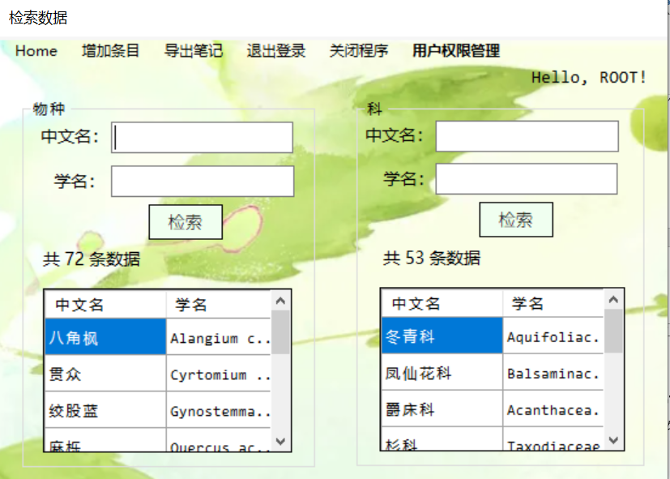

**(2) 功能**

* 中文名字段检索（名字或别名存在相似字段）
* 点击物种条目，跳转对应物种信息界面
* 点击科条目，跳转对应科信息界面

**(3)** **代码**

using System;

using System.Collections.Generic;

using System.ComponentModel;

using System.Data;

using System.Drawing;

using System.Linq;

using System.Text;

using System.Threading.Tasks;

using System.Windows.Forms;

using System.Data.SqlClient;

using Excel = Microsoft.Office.Interop.Excel;

namespace PlantDB

{

public partial class Retrieve : Form

{

SqlConnection conn = new SqlConnection

("DataBase=PlantInfo; Data Source=(local); Integrated Security = True;");

String usr_mode, usrname;

public Retrieve(String mode, String usrname)

{

InitializeComponent();

usr_mode = mode;

this.usrname = usrname;

this.label7.Text += usrname + "!";

switch (mode)

{

case "Guest": loadAsGuest(); break;

case "C": loadAsUser(usrname); break;

case "A": loadAsAdmin(usrname); break;

case "R": loadAsRoot(); break;

default: break;

}

this.Show();

}

private void loadAsGuest()

{

this.menuStrip1.Items[2].Visible = false;

this.menuStrip1.Items[4].Visible = false;

this.menuStrip1.Items[6].Visible = false;

}

private void loadAsRoot()

{

this.menuStrip1.Items[3].Visible = false;

}

private void loadAsAdmin(String name)

{

this.menuStrip1.Items[3].Visible = false;

this.menuStrip1.Items[6].Visible = false;

}

private void loadAsUser(String name)

{

this.menuStrip1.Items[3].Visible = false;

this.menuStrip1.Items[6].Visible = false;

}

private void Retrieve_Load(object sender, EventArgs e)

{

String sql1 = "SELECT TOP 10 sname AS '中文名', sLatin AS '学名' FROM Species";

SqlDataAdapter adapter = new SqlDataAdapter(sql1, conn);

DataSet ds = new DataSet();

adapter.Fill(ds);

DataTable dt = ds.Tables[0].DefaultView.ToTable(false, new String[] { "中文名", "学名" });

dataGridView1.DataSource = dt.DefaultView;

String sql2 = "SELECT TOP 10 fname AS '中文名', fLatin AS '学名' FROM Family";

ds = new DataSet();

adapter = new SqlDataAdapter(sql2, conn);

adapter.Fill(ds);

dt = ds.Tables[0].DefaultView.ToTable(false, new String[] { "中文名", "学名" });

dataGridView2.DataSource = dt.DefaultView;

conn.Open();

String summary = "SELECT COUNT(S.spid) AS SP_NUM FROM Species AS S;";

SqlCommand cmd = new SqlCommand(summary, conn);

SqlDataReader reader = cmd.ExecuteReader();

reader.Read();

this.label5.Text = "共 " + reader["SP_NUM"].ToString() + " 条数据";

reader.Close();

summary = "SELECT COUNT(F.fid) AS FM_NUM FROM Family AS F;";

cmd = new SqlCommand(summary, conn);

reader = cmd.ExecuteReader();

reader.Read();

this.label6.Text = "共 " + reader["FM_NUM"].ToString() + " 条数据";

conn.Close();

}

private void button1_Click(object sender, EventArgs e)

{

String name = this.textBox1.Text.Trim();

String latin = this.textBox3.Text.Trim();

if (name == "") name = "NONE";

if (latin == "") latin = "NONE";

String sql = "SELECT sname AS '中文名', nickname AS '别称', sLatin AS '学名' FROM Species " +

"WHERE sname LIKE '%" + name + "%' OR nickname LIKE '%" + name + "%' OR sLatin LIKE '%" + latin + "%';";

SqlDataAdapter adapter = new SqlDataAdapter(sql, conn);

DataSet ds = new DataSet();

adapter.Fill(ds);

if (ds.Tables[0].Rows.Count != 0)

{

DataTable dt = ds.Tables[0].DefaultView.ToTable(false, new String[] { "中文名", "别称", "学名" });

dataGridView1.DataSource = dt.DefaultView;

dataGridView1.ScrollBars = ScrollBars.Both;

this.label5.Text = "共 " + dt.Rows.Count.ToString() + " 条数据";

}

else {

MessageBox.Show("物种 检索失败！\n请重新输入词条 或 申请创建词条");

}

}

private void button2_Click(object sender, EventArgs e)

{

String name = this.textBox2.Text.Trim();

String latin = this.textBox4.Text.Trim();

if (name == "") name = "NONE";

if (latin == "") latin = "NONE";

String sql = "SELECT fname AS '中文名', fLatin AS '学名' FROM Family " +

"WHERE fname LIKE '%" + name + "%' OR fLatin LIKE '%" + latin + "%';";

SqlDataAdapter adapter = new SqlDataAdapter(sql, conn);

DataSet ds = new DataSet();

adapter.Fill(ds);

if (ds.Tables[0].Rows.Count != 0)

{

DataTable dt = ds.Tables[0].DefaultView.ToTable(false, new String[] { "中文名", "学名" });

dataGridView2.DataSource = dt.DefaultView;

this.label6.Text = "共 " + dt.Rows.Count.ToString() + " 条数据";

}

else

{

MessageBox.Show("科 检索失败！\n请重新输入词条 或 申请创建词条");

}

}

private void dataGridView1_CellClick(object sender, DataGridViewCellEventArgs e)

{

if (e.RowIndex >= 0)

{

String spname = this.dataGridView1.Rows[e.RowIndex].Cells[0].Value.ToString();

Form species = new SpeciesInfo(spname, usr_mode, usrname);

this.Close();

}

}

private void dataGridView2_CellClick(object sender, DataGridViewCellEventArgs e)

{

if (e.RowIndex >= 0)

{

String fname = this.dataGridView2.Rows[e.RowIndex].Cells[0].Value.ToString();

Form family = new FamilyInfo(fname, usr_mode, usrname);

this.Close();

}

}

private void 登陆ToolStripMenuItem_Click(object sender, EventArgs e)

{

Form login = new LogIn();

login.Show();

this.Close();

}

private void 退出登录ToolStripMenuItem_Click(object sender, EventArgs e)

{

DialogResult re = MessageBox.Show("确认要退出登录吗？", "提示", MessageBoxButtons.OKCancel, MessageBoxIcon.Question);

if (re == DialogResult.OK)

{

Form login = new LogIn();

this.Close();

}

}

private void 关闭程序ToolStripMenuItem_Click(object sender, EventArgs e)

{

Application.Exit();

}

private void HomeToolStripMenuItem_Click(object sender, EventArgs e)

{

Form home = new Home(usr_mode, usrname);

this.Close();

}

private void 物种ToolStripMenuItem_Click(object sender, EventArgs e)

{

Form species;

if (usr_mode == "A" || usr_mode == "R") {

species = new SpeciesInfo("new", usr_mode, usrname, true);

this.Close();

}

else MessageBox.Show("对不起！\n您不具有管理权限，不能进行该操作", "提示", MessageBoxButtons.OK, MessageBoxIcon.Error);

}

private void 科ToolStripMenuItem_Click(object sender, EventArgs e)

{

Form family;

if (usr_mode == "A" || usr_mode == "R") {

family = new FamilyInfo("new", usr_mode, usrname, true);

this.Close();

}

else MessageBox.Show("对不起！\n您不具有管理权限，不能进行该操作", "提示", MessageBoxButtons.OK, MessageBoxIcon.Error);

}

private void 导出笔记ToolStripMenuItem_Click(object sender, EventArgs e)

{

}

private void 物种笔记ToolStripMenuItem_Click(object sender, EventArgs e)

{

Excel.Application app = new Excel.Application();

Excel.Workbook wb = app.Workbooks.Add();

Excel.Worksheet ws;

app.SheetsInNewWorkbook = 1;

app.Caption = "Species_Info.xlsx";

ws = wb.Worksheets[1];

ws.Cells.Item[1, 1] = "物种名";

ws.Cells.Item[1, 2] = "学名";

ws.Cells.Item[1, 3] = "科名";

ws.Cells.Item[1, 4] = "生长环境";

ws.Cells.Item[1, 5] = "分布地域";

ws.Cells.Item[1, 6] = "描述";

ws.Cells.Item[1, 7] = "笔记";

String sql = "SELECT sname, sLatin, family, env, region, sdesp, content " +

"FROM Species RIGHT JOIN SNotes ON Species.spid = SNotes.spid " +

"RIGHT JOIN Users ON Users.usrid = SNotes.usrid " +

"WHERE SNotes.isPublic = 0 AND Users.usrname ='" + usrname + "'; ";

SqlCommand cmd = new SqlCommand(sql, conn);

conn.Open();

SqlDataReader reader = cmd.ExecuteReader();

int i = 1;

while (reader.Read())

{

ws.Cells.Item[++i, 1] = reader[0].ToString();

ws.Cells.Item[i, 2] = reader[1].ToString();

ws.Cells.Item[i, 3] = reader[2].ToString();

ws.Cells.Item[i, 4] = reader[3].ToString();

ws.Cells.Item[i, 5] = reader[4].ToString();

ws.Cells.Item[i, 6] = reader[5].ToString();

ws.Cells.Item[i, 7] = reader[6].ToString();

}

conn.Close();

app.Visible = true;

}

private void 科笔记ToolStripMenuItem_Click(object sender, EventArgs e)

{

Excel.Application app = new Excel.Application();

Excel.Workbook wb = app.Workbooks.Add();

Excel.Worksheet ws;

app.SheetsInNewWorkbook = 1;

app.Caption = "Species_Info.xlsx";

ws = wb.Worksheets[1];

ws.Cells.Item[1, 1] = "科名";

ws.Cells.Item[1, 2] = "学名";

ws.Cells.Item[1, 3] = "描述";

ws.Cells.Item[1, 4] = "笔记";

String sql = "SELECT fname, fLatin, fdesp, content " +

"FROM Family RIGHT JOIN FNotes ON Family.fid = FNotes.fid " +

"RIGHT JOIN Users ON Users.usrid = FNotes.usrid " +

"WHERE FNotes.isPublic = 0 AND Users.usrname ='" + usrname + "'; ";

SqlCommand cmd = new SqlCommand(sql, conn);

conn.Open();

SqlDataReader reader = cmd.ExecuteReader();

int i = 1;

while (reader.Read())

{

ws.Cells.Item[++i, 1] = reader[0].ToString();

ws.Cells.Item[i, 2] = reader[1].ToString();

ws.Cells.Item[i, 3] = reader[2].ToString();

ws.Cells.Item[i, 4] = reader[3].ToString();

}

conn.Close();

app.Visible = true;

}

private void textBox1_KeyDown(object sender, KeyEventArgs e)

{

if (e.KeyCode == Keys.Enter)

button1_Click(sender, e);

}

private void textBox3_KeyDown(object sender, KeyEventArgs e)

{

if (e.KeyCode == Keys.Enter)

button1_Click(sender, e);

}

private void textBox2_KeyDown(object sender, KeyEventArgs e)

{

if (e.KeyCode == Keys.Enter)

button1_Click(sender, e);

}

private void textBox4_KeyDown(object sender, KeyEventArgs e)

{

if (e.KeyCode == Keys.Enter)

button1_Click(sender, e);

}

private void 用户管理ToolStripMenuItem_Click(object sender, EventArgs e)

{

Form edit = new AdminEdit(usr_mode, usrname);

this.Close();

}

}

}

5. 物种信息查看界面

**(1) 界面展示**

管理员模式：（可编辑页面）

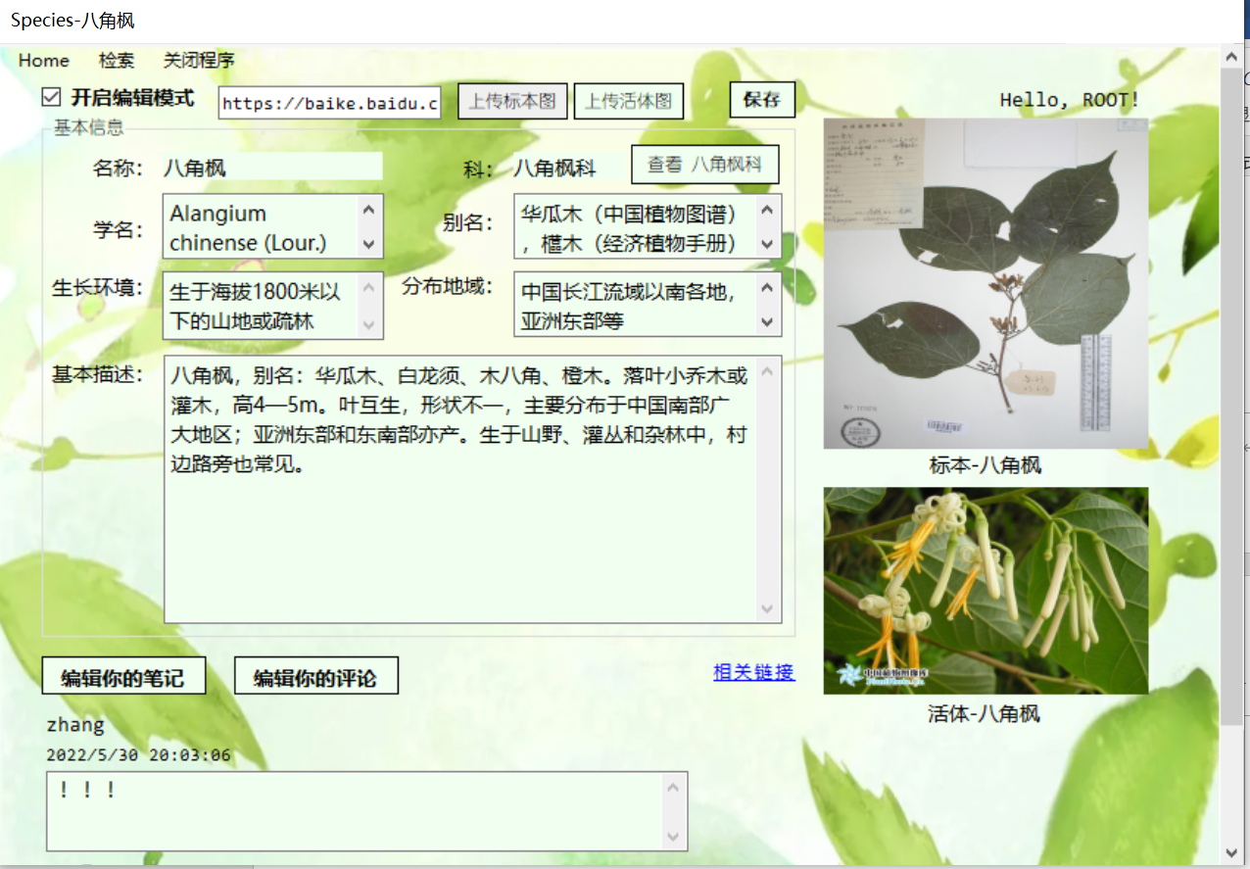

普通用户/游客模式：

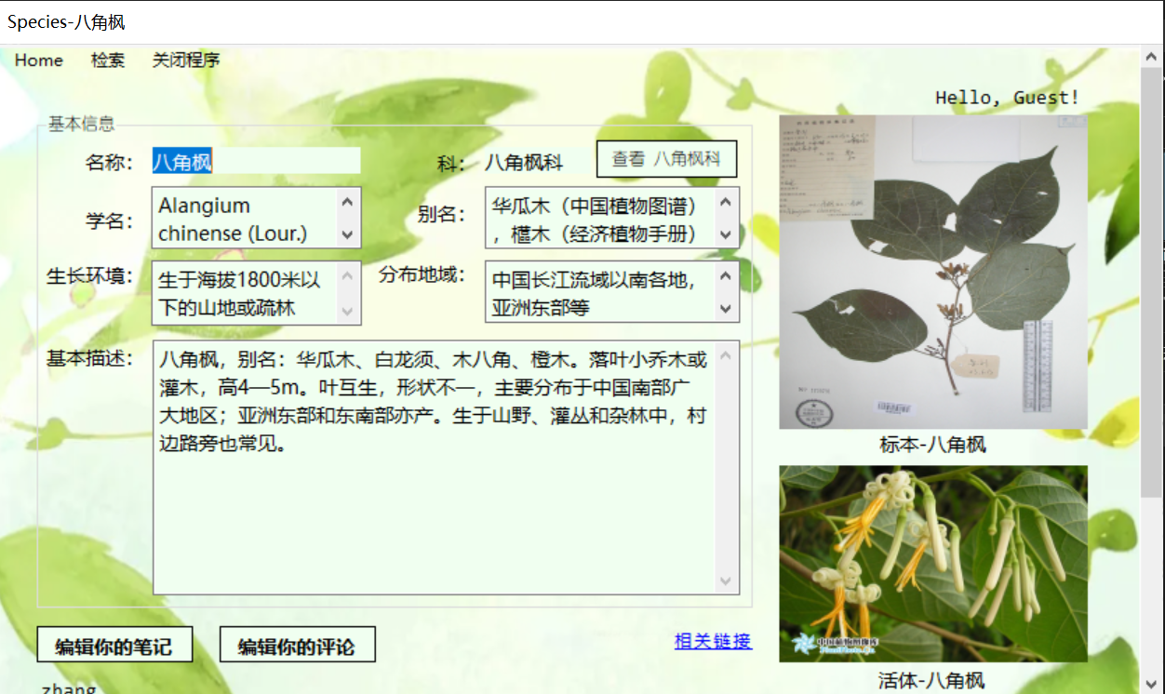

**(2) 功能**

查看物种相关信息

**(3) 代码**

using System;

using System.Collections.Generic;

using System.ComponentModel;

using System.Data;

using System.Drawing;

using System.Linq;

using System.Text;

using System.Threading.Tasks;

using System.Windows.Forms;

using System.Data.SqlClient;

using System.IO;

using System.Diagnostics;

namespace PlantDB

{

public partial class SpeciesInfo : Form

{

SqlConnection conn = new SqlConnection

("DataBase=PlantInfo; Data Source=(local); Integrated Security = True;");

private String usr_mode, usrname, card_id;

private String new_pic1_path = "", new_pic2_path = "";

bool isAddition;

public SpeciesInfo(String spname, String mode, String usrname, bool isAddition = false)

{

InitializeComponent();

usr_mode = mode;

this.usrname = usrname;

this.label11.Text += usrname + "!";

this.isAddition = isAddition;

if (isAddition)

{

isEditable(true);

button1.Visible = false;

button2.Visible = false;

button3.Visible = false;

linkLabel1.Visible = false;

addNote.Visible = true;

textBox8.Text = "输入新链接";

textBox8.ForeColor = Color.Gray;

textBox7.Text = "不超过600字";

textBox7.ForeColor = Color.Gray;

}

else {

load_info(spname);

load_comments(new Point(25, 450), 100);

if (mode == "A" || mode == "R") checkBox1.Visible = true;

}

this.Show();

}

private void load_info(String name) {

this.Text += '-' + name;

this.label8.Text += name;

this.label9.Text += name;

conn.Open();

String sql = "SELECT spid, sname, nickname, sLatin, family, env, region, specimen_img, colorful_img, sdesp, link " +

"FROM Species WHERE sname = '" + name + "'";

SqlCommand cmd = new SqlCommand(sql, conn);

SqlDataReader dr = cmd.ExecuteReader();

if (dr.Read())

{

card_id = dr["spid"].ToString();

this.textBox1.Text = dr["sname"].ToString();

this.textBox2.Text = dr["sLatin"].ToString();

this.textBox3.Text = dr["env"].ToString();

this.textBox4.Text = dr["nickname"].ToString();

this.textBox5.Text = dr["family"].ToString();

this.textBox6.Text = dr["region"].ToString();

this.textBox7.Text = dr["sdesp"].ToString();

this.linkLabel1.Tag = dr["link"].ToString();

if (!dr.IsDBNull(6)) {

byte[] img1 = (byte[])dr["specimen_img"];

MemoryStream stream1 = new MemoryStream(img1);

this.pictureBox1.Image = Image.FromStream(stream1, true);

stream1.Close();

}

if (!dr.IsDBNull(7))

{

byte[] img2 = (byte[])dr["colorful_img"];

MemoryStream stream2 = new MemoryStream(img2);

this.pictureBox2.Image = Image.FromStream(stream2, true);

stream2.Close();

}

this.button1.Text += this.textBox5.Text;

}

else {

MessageBox.Show("No such species!");

}

conn.Close();

}

private void load_comments(Point start, int height)

{

String sql = "SELECT usrname AS name, content AS comment, lastEditTime AS time" +

" FROM SNotes LEFT JOIN Users ON SNotes.usrid = Users.usrid" +

" WHERE isPublic = 1 AND spid = '" + card_id + "' ORDER BY time DESC; ";

SqlCommand cmd = new SqlCommand(sql, conn);

conn.Open();

SqlDataReader reader = cmd.ExecuteReader();

int index = 0;

while (reader.Read())

{

this.Controls.Add(new CommentBar(reader["name"].ToString(),

reader["comment"].ToString(),

reader["time"].ToString(), start.X, start.Y + height * index++));

}

conn.Close();

}

private void button1_Click(object sender, EventArgs e)

{

Form family = new FamilyInfo(this.textBox5.Text, usr_mode, usrname);

family.Show();

this.Close();

}

private void linkLabel1_LinkClicked(object sender, LinkLabelLinkClickedEventArgs e)

{

Process.Start(linkLabel1.Tag.ToString());

}

private void homeToolStripMenuItem_Click(object sender, EventArgs e)

{

Form home = new Home(usr_mode, usrname);

this.Close();

}

private void 关闭程序ToolStripMenuItem_Click(object sender, EventArgs e)

{

Application.Exit();

}

private void button2_Click(object sender, EventArgs e)

{

Form note;

if (usr_mode == "Guest") {

DialogResult re = MessageBox.Show("当前为游客登录，请先创建账号！\n是否转到注册界面？", "提示", MessageBoxButtons.YesNo, MessageBoxIcon.Exclamation);

if (re == DialogResult.Yes)

note = new SignUp();

else return;

}

else note = new NoteEdit(usr_mode, usrname, this.textBox1.Text, 'S', '0');

this.Close();

}

private void button3_Click(object sender, EventArgs e)

{

Form note;

if (usr_mode == "Guest")

{

DialogResult re = MessageBox.Show("当前为游客登录，请先创建账号！\n是否转到注册界面？", "提示", MessageBoxButtons.YesNo, MessageBoxIcon.Exclamation);

if (re == DialogResult.Yes)

note = new SignUp();

else return;

}

else note = new NoteEdit(usr_mode, usrname, this.textBox1.Text, 'S', '1');

this.Close();

}

private void checkBox1_CheckedChanged(object sender, EventArgs e)

{

isEditable(checkBox1.Checked);

}

private void isEditable(bool tick) {

textBox1.ReadOnly = !tick;

textBox2.ReadOnly = !tick;

textBox3.ReadOnly = !tick;

textBox4.ReadOnly = !tick;

textBox5.ReadOnly = !tick;

textBox6.ReadOnly = !tick;

textBox7.ReadOnly = !tick;

textBox8.Visible = tick;

textBox8.Text = linkLabel1.Tag.ToString();

button4.Visible = tick;

button5.Visible = tick;

save.Visible = tick;

}

private void button5_Click(object sender, EventArgs e)

{

OpenFileDialog pic2 = new OpenFileDialog();

pic2.Filter = "Pictures (*.jpg;*.png)|*.jpg;*.png";

pic2.FilterIndex = 0;

if (pic2.ShowDialog() == DialogResult.OK)

this.pictureBox2.Load(this.new_pic2_path = pic2.FileName);

}

private void save_Click(object sender, EventArgs e)

{

if (isAddition)

insertNewInfo();

else

updateInfo();

}

private void updateInfo() {

String sql = "UPDATE Species " +

"SET sname = '" + textBox1.Text + "', " +

"sLatin = '" + textBox2.Text + "', " +

"env = '" + textBox3.Text + "', " +

"nickname = '" + textBox4.Text + "', " +

"family = '" + textBox5.Text + "', " +

"region = '" + textBox6.Text + "', " +

"sdesp = '" + textBox7.Text + "', " +

"link = '" + textBox8.Text + "', " +

"lastEditTime = GETDATE()";

if (new_pic1_path != "")

sql += ", specimen_img = " +

"(SELECT * FROM OPENROWSET(BULK '" + new_pic1_path + "', SINGLE_BLOB) AS img1)";

if (new_pic2_path != "")

sql += ", colorful_img = " +

"(SELECT * FROM OPENROWSET(BULK '" + new_pic2_path + "', SINGLE_BLOB) AS img2)";

sql += " WHERE spid = '" + card_id + "';";

SqlCommand cmd = new SqlCommand(sql, conn);

conn.Open();

cmd.ExecuteNonQuery();

conn.Close();

MessageBox.Show("数据更新成功！");

}

private void insertNewInfo() {

if (textBox1.Text == "")

{

MessageBox.Show("物种名必须填写！");

textBox1.Focus();

return;

}

else if (textBox2.Text == "")

{

MessageBox.Show("学名必须填写！");

textBox2.Focus();

return;

}

else if (textBox3.Text == "")

{

MessageBox.Show("生长环境必须填写！");

textBox3.Focus();

return;

}

else if (textBox7.Text == "")

{

MessageBox.Show("基本描述必须填写！");

textBox7.Focus();

return;

}

else if (textBox3.Text.Trim().Length > 600)

{

MessageBox.Show("基本描述不应超过600字！", "提示", MessageBoxButtons.OK, MessageBoxIcon.Error);

return;

}

else if (textBox5.Text == "")

{

MessageBox.Show("科必须填写！");

textBox5.Focus();

return;

}

else if (isNewFamily(textBox5.Text.Trim())) {

DialogResult re = MessageBox.Show("检测到新的科！\n请先添加该科相关条目，是否跳转？", "提示", MessageBoxButtons.YesNo, MessageBoxIcon.Question); ;

Form add;

if (re == DialogResult.Yes) {

add = new FamilyInfo("new", usr_mode, usrname, true);

this.Close();

}

return;

}

else if (textBox6.Text == "")

{

MessageBox.Show("分布地域必须填写！");

textBox6.Focus();

return;

}

else;

String pic1_val, pic2_val, link_val, nickname_val;

if (new_pic1_path == "") pic1_val = "NULL"; else pic1_val = "(SELECT * FROM OPENROWSET(BULK '" + new_pic1_path + "', SINGLE_BLOB) AS img1)";

if (new_pic2_path == "") pic2_val = "NULL"; else pic2_val = "(SELECT * FROM OPENROWSET(BULK '" + new_pic2_path + "', SINGLE_BLOB) AS img1)";

if (textBox4.Text == "") nickname_val = "NULL"; else nickname_val = "'" + textBox4.Text + "'";

if (textBox8.Text == "") link_val = "NULL"; else link_val = "'" + textBox8.Text + "'";

String sql = "INSERT INTO Species(sname, sLatin, family, env, region, sdesp, nickname, link, specimen_img, colorful_img) " +

"VALUES('" + textBox1.Text.Trim() + "', '" +

textBox2.Text.Trim() + "', '" +

textBox5.Text.Trim() + "', '" +

textBox3.Text.Trim() + "', '" +

textBox6.Text.Trim() + "', '" +

textBox7.Text.Trim() + "', " + nickname_val + ", " + link_val + ", " + pic1_val + ", " + pic2_val + ");";

SqlCommand cmd = new SqlCommand(sql, conn);

conn.Open();

cmd.ExecuteNonQuery();

conn.Close();

MessageBox.Show("添加成功！");

Form home = new Home(usr_mode, usrname);

this.Close();

}

private void textBox7_MouseHover(object sender, EventArgs e)

{

if (isAddition){

textBox7.ForeColor = Color.Black;

textBox7.Text = "";

}

}

private void textBox7_MouseLeave(object sender, EventArgs e)

{

if (isAddition)

{

textBox7.Text = "不超过600字";

textBox7.ForeColor = Color.Gray;

}

}

private bool isNewFamily(String fname) {

String sql = "SELECT fname FROM Family WHERE fname = '" + fname + "';";

SqlCommand cmd = new SqlCommand(sql, conn);

conn.Open();

SqlDataReader rd = cmd.ExecuteReader();

bool re = !rd.HasRows;

conn.Close();

return re;

}

private void button4_Click(object sender, EventArgs e)

{

OpenFileDialog pic1 = new OpenFileDialog();

pic1.Filter = "Pictures (*.jpg;*.png)|*.jpg;*.png";

pic1.FilterIndex = 0;

if (pic1.ShowDialog() == DialogResult.OK)

this.pictureBox1.Load(this.new_pic1_path = pic1.FileName);

}

private void 检索ToolStripMenuItem_Click(object sender, EventArgs e)

{

Form search = new Retrieve(usr_mode, usrname);

this.Close();

}

}

}

6. 科信息查看界面

**(1) 界面展示**

管理员模式：（可编辑页面）

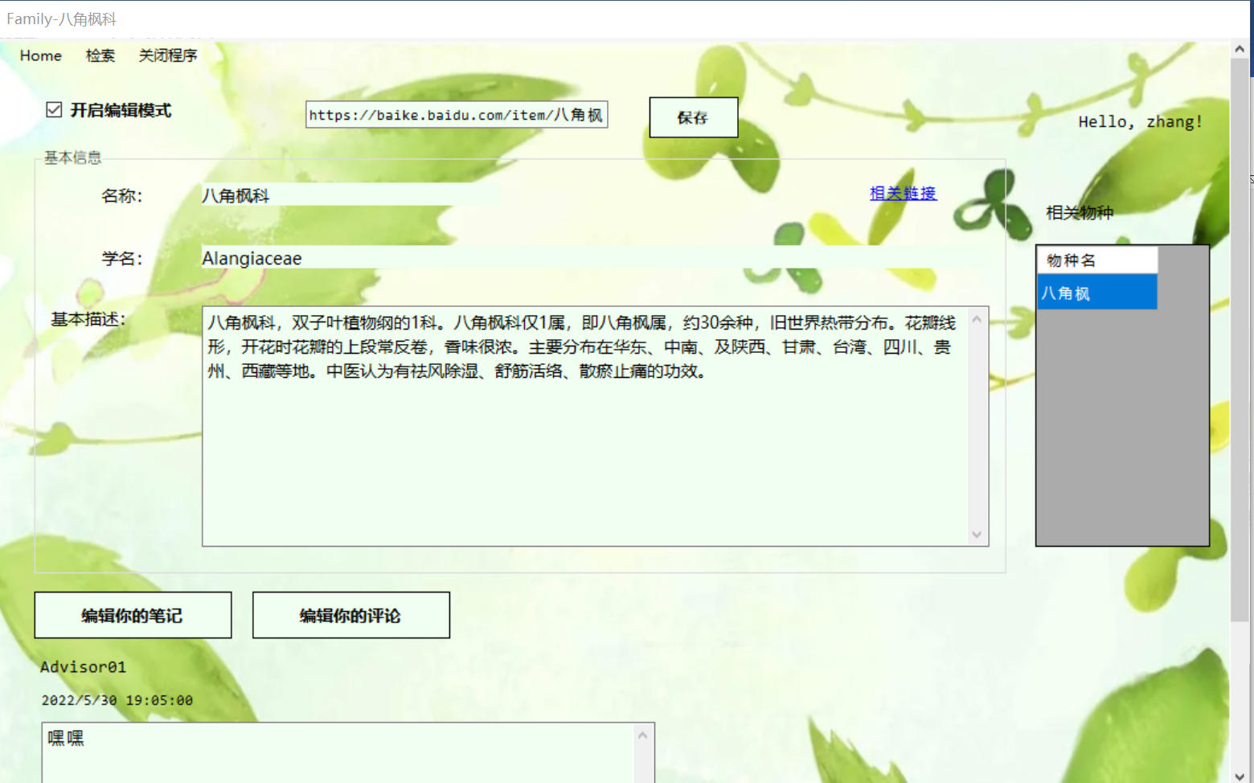

普通用户/游客模式：

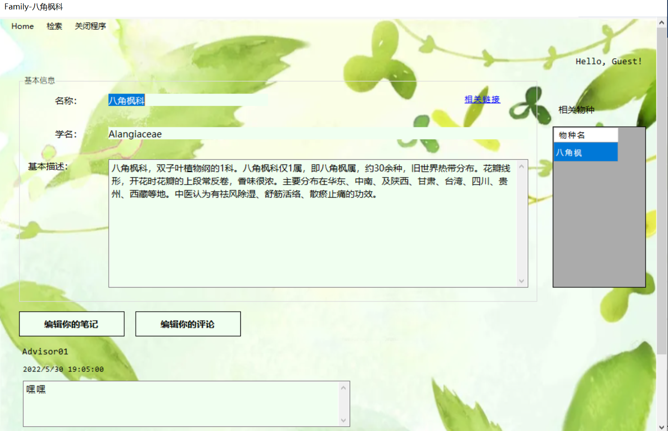

**(2) 功能**

查看科相关信息

**(3) 代码**

using System;

using System.Collections.Generic;

using System.ComponentModel;

using System.Data;

using System.Drawing;

using System.Linq;

using System.Text;

using System.Threading.Tasks;

using System.Windows.Forms;

using System.Data.SqlClient;

using System.Diagnostics;

namespace PlantDB

{

public partial class FamilyInfo : Form

{

SqlConnection conn = new SqlConnection

("DataBase=PlantInfo; Data Source=(local); Integrated Security = True;");

private String usr_mode, usrname, card_id;

bool isAddition;

public FamilyInfo(String fname, String mode, String usrname, bool isAddition = false)

{

InitializeComponent();

usr_mode = mode;

this.usrname = usrname;

this.label5.Text += usrname + "!";

this.isAddition = isAddition;

if (isAddition)

{

isEditable(true);

button1.Visible = false;

button2.Visible = false;

linkLabel1.Visible = false;

dataGridView1.Visible = false;

label4.Visible = false;

addNote.Visible = true;

textBox4.Text = "输入新链接";

textBox3.Text = "不超过500字";

textBox4.ForeColor = Color.Gray;

textBox3.ForeColor = Color.Gray;

}

else {

load_info(fname);

load_comments(new Point(25, 380), 100);

if (mode == "R" || mode == "A") checkBox1.Visible = true;

}

this.Show();

}

private void load_comments(Point start, int height) {

String sql = "SELECT usrname AS name, content AS comment, lastEditTime AS time" +

" FROM FNotes LEFT JOIN Users ON FNotes.usrid = Users.usrid" +

" WHERE isPublic = 1 AND fid = '" + card_id + "' ORDER BY time DESC; ";

SqlCommand cmd = new SqlCommand(sql, conn);

conn.Open();

SqlDataReader reader = cmd.ExecuteReader();

int index = 0;

while (reader.Read())

{

this.Controls.Add(new CommentBar(reader["name"].ToString(),

reader["comment"].ToString(),

reader["time"].ToString(), start.X, start.Y + height * index++));

}

conn.Close();

}

private void load_info(String name) {

this.Text += '-' + name;

conn.Open();

String sql = "SELECT fid, fname, fLatin, fdesp, link " +

"FROM Family WHERE fname = '" + name + "'";

SqlCommand cmd = new SqlCommand(sql, conn);

SqlDataReader dr = cmd.ExecuteReader();

if (dr.Read())

{

card_id = dr["fid"].ToString();

this.textBox1.Text = dr["fname"].ToString();

this.textBox2.Text = dr["fLatin"].ToString();

this.textBox3.Text = dr["fdesp"].ToString();

this.linkLabel1.Tag = dr["link"].ToString();

conn.Close();

String related_species = "SELECT sname AS '物种名' FROM Species " +

"WHERE family = '" + textBox1.Text + "';";

SqlDataAdapter adapter = new SqlDataAdapter(related_species, conn);

DataSet ds = new DataSet();

adapter.Fill(ds);

if (ds.Tables[0].Rows.Count != 0)

{

DataTable dt = ds.Tables[0].DefaultView.ToTable(false, new String[] { "物种名" });

dataGridView1.DataSource = dt.DefaultView;

}

}

else

{

MessageBox.Show("No such Family!");

}

}

private void button1_Click(object sender, EventArgs e)

{

Form note;

if (usr_mode == "Guest")

{

DialogResult re = MessageBox.Show("当前为游客登录，请先创建账号！\n是否转到注册界面？", "提示", MessageBoxButtons.YesNo, MessageBoxIcon.Exclamation);

if (re == DialogResult.Yes)

note = new SignUp();

else return;

}

else note = new NoteEdit(usr_mode, usrname, this.textBox1.Text, 'F', '0');

this.Close();

}

private void homeToolStripMenuItem_Click(object sender, EventArgs e)

{

Form home = new Home(usr_mode, usrname);

this.Close();

}

private void 检索ToolStripMenuItem_Click(object sender, EventArgs e)

{

Form search = new Retrieve(usr_mode, usrname);

this.Close();

}

private void 关闭程序ToolStripMenuItem_Click(object sender, EventArgs e)

{

Application.Exit();

}

private void dataGridView1_CellClick(object sender, DataGridViewCellEventArgs e)

{

if (e.RowIndex >= 0)

{

String spname = this.dataGridView1.Rows[e.RowIndex].Cells[0].Value.ToString();

Form species = new SpeciesInfo(spname, usr_mode, usrname);

this.Close();

}

}

private void checkBox1_CheckedChanged(object sender, EventArgs e)

{

isEditable(checkBox1.Checked);

}

private void isEditable(bool tick) {

textBox1.ReadOnly = !tick;

textBox2.ReadOnly = !tick;

textBox3.ReadOnly = !tick;

textBox4.Visible = tick;

textBox4.Text = linkLabel1.Tag.ToString();

save.Visible = tick;

}

private void button2_Click(object sender, EventArgs e)

{

Form note;

if (usr_mode == "Guest")

{

DialogResult re = MessageBox.Show("当前为游客登录，请先创建账号！\n是否转到注册界面？", "提示", MessageBoxButtons.YesNo, MessageBoxIcon.Exclamation);

if (re == DialogResult.Yes)

note = new SignUp();

else return;

}

else note = new NoteEdit(usr_mode, usrname, this.textBox1.Text, 'F', '1');

this.Close();

}

private void save_Click(object sender, EventArgs e)

{

if (isAddition)

insertInfo();

else

updateInfo();

}

private void updateInfo() {

linkLabel1.Tag = textBox4.Text;

String sql = "UPDATE Family " +

"SET fname = '" + textBox1.Text + "', link = '" + textBox4.Text + "', " +

"fLatin = '" + textBox2.Text + "', fdesp = '" + textBox3.Text + "', lastEditTime = GETDATE() " +

"WHERE fid = '" + card_id + "';";

SqlCommand cmd = new SqlCommand(sql, conn);

conn.Open();

cmd.ExecuteNonQuery();

conn.Close();

Form card = new FamilyInfo(textBox1.Text, usr_mode, usrname);

this.Close();

}

private void textBox3_MouseHover(object sender, EventArgs e)

{

if (isAddition) {

textBox3.ForeColor = Color.Black;

textBox3.Text = "";

}

}

private void textBox3_MouseLeave(object sender, EventArgs e)

{

if (isAddition) {

textBox3.ForeColor = Color.Gray;

textBox3.Text = "不超过500字";

}

}

private void insertInfo() {

if (textBox3.Text.Trim().Length > 500)

{

MessageBox.Show("基本描述不应超过500字！", "提示", MessageBoxButtons.OK, MessageBoxIcon.Error);

textBox3.Focus();

return;

}

else if (textBox1.Text == "")

{

MessageBox.Show("科名必须填写！");

textBox1.Focus();

return;

}

else if (textBox2.Text == "")

{

MessageBox.Show("学名必须填写！");

textBox2.Focus();

return;

}

else if (textBox3.Text == "")

{

MessageBox.Show("基本描述必须填写！");

textBox3.Focus();

return;

}

else;

String link_val;

if (textBox4.Text == "") link_val = "NULL"; else link_val = "'" + textBox4.Text.Trim() + "'";

String sql = "INSERT INTO Family(fname, fLatin, fdesp, link) " +

"VALUES('" + textBox1.Text.Trim() + "', '" +

textBox2.Text.Trim() + "', '" +

textBox3.Text.Trim() + "', " + link_val + ");";

SqlCommand cmd = new SqlCommand(sql, conn);

conn.Open();

cmd.ExecuteNonQuery();

conn.Close();

MessageBox.Show("添加成功！");

Form home = new Home(usr_mode, usrname);

this.Close();

}

private void linkLabel1_LinkClicked(object sender, LinkLabelLinkClickedEventArgs e)

{

Process.Start(linkLabel1.Tag.ToString());

}

}

}

7. 物种/科笔记编辑界面

**(1) 界面展示**

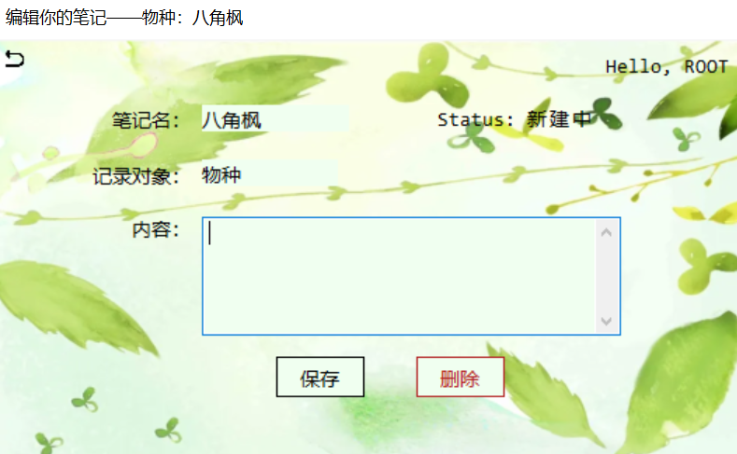

**(2) 功能**

增加、编辑、删除与科/物种相关的笔记

**(3) 代码**

using System;

using System.Collections.Generic;

using System.ComponentModel;

using System.Data;

using System.Drawing;

using System.Linq;

using System.Text;

using System.Threading.Tasks;

using System.Windows.Forms;

using System.Data.SqlClient;

namespace PlantDB

{

public partial class NoteEdit : Form

{

SqlConnection conn = new SqlConnection

("DataBase=PlantInfo; Data Source=(local); Integrated Security = True;");

private String usr_mode, usrname, obj; char obj_type, status, note_type;

public NoteEdit(String mode, String usrname, String obj_name, char obj_type, char note_type)

{

InitializeComponent();

this.usr_mode = mode;

this.usrname = usrname;

this.obj = obj_name;

this.obj_type = obj_type;

this.note_type = note_type;

this.Text += (note_type == '0' ? "笔记" : "评论") + "——";

this.textBox1.Text = this.obj;

this.label1.Text += usrname;

this.Show();

this.textBox3.Focus();

}

private void NoteEdit_Load(object sender, EventArgs e)

{

if (obj_type == 'F')

loadFamily();

else if (obj_type == 'S')

loadSpecies();

else;

}

private void loadFamily() {

this.Text += "科：" + obj;

this.textBox2.Text = "科";

String sql = "SELECT content FROM FNotes " +

"WHERE fid = (SELECT fid FROM Family WHERE fname = '" + this.obj + "')" +

"AND usrid = (SELECT usrid FROM Users WHERE usrname = '" + this.usrname + "') " +

"AND isPublic = " + note_type + ";";

SqlCommand cmd = new SqlCommand(sql, conn);

conn.Open();

SqlDataReader reader = cmd.ExecuteReader();

if (reader.HasRows)

{

reader.Read();

this.textBox3.Text = reader[0].ToString();

this.status = 'E';

this.status_label.Text += "编辑中";

}

else

{

this.status = 'A';

this.status_label.Text += "新建中";

}

conn.Close();

}

private void back_Click(object sender, EventArgs e)

{

Form info;

if (obj_type == 'S')

info = new SpeciesInfo(obj, usr_mode, usrname);

else

info = new FamilyInfo(obj, usr_mode, usrname);

this.Close();

}

private void button2_Click(object sender, EventArgs e)

{

if (status == 'A')

MessageBox.Show("删除失败！\n笔记还未创建！", "提示", MessageBoxButtons.OK, MessageBoxIcon.Error);

else {

if (obj_type == 'S')

run_sql("DELETE FROM SNotes " +

"WHERE spid = (SELECT spid FROM Species WHERE sname = '" + obj + "') " +

"AND usrid = (SELECT usrid FROM Users WHERE usrname = '" + usrname + "');");

else

run_sql("DELETE FROM FNotes " +

"WHERE fid = (SELECT fid FROM Family WHERE fname = '" + obj + "') " +

"AND usrid = (SELECT usrid FROM Users WHERE usrname = '" + usrname + "');");

MessageBox.Show("删除成功！");

this.status_label.Text = "Status: 新建中";

this.status = 'A';

this.textBox3.Text = "";

}

}

private void loadSpecies() {

this.Text += "物种：" + obj;

this.textBox2.Text = "物种";

String sql = "SELECT content FROM SNotes " +

"WHERE spid = (SELECT spid FROM Species WHERE sname = '" + this.obj + "')" +

"AND usrid = (SELECT usrid FROM Users WHERE usrname = '" + this.usrname + "') " +

"AND isPublic = " + note_type + ";";

SqlCommand cmd = new SqlCommand(sql, conn);

conn.Open();

SqlDataReader reader = cmd.ExecuteReader();

if (reader.HasRows)

{

reader.Read();

this.textBox3.Text = reader[0].ToString();

this.status = 'E';

this.status_label.Text += "编辑中";

}

else {

this.status = 'A';

this.status_label.Text += "新建中";

}

conn.Close();

}

private void button1_Click(object sender, EventArgs e)

{

if (this.textBox3.Text.Length > 0 && this.textBox3.Text.Length <= 200)

{

String content = this.textBox3.Text.Trim();

if (status == 'E')

if (obj_type == 'S')

{

run_sql("UPDATE SNotes" +

" SET content = '" + content + "', lastEditTime = GETDATE()" +

" WHERE usrid = (SELECT usrid FROM Users WHERE usrname = '" + usrname + "') " +

" AND spid = (SELECT spid FROM Species WHERE sname = '" + obj + "')" +

" AND isPublic = "+ note_type +"; ");

}

else

{

run_sql("UPDATE FNotes" +

" SET content = '" + content + "', lastEditTime = GETDATE()" +

" WHERE usrid = (SELECT usrid FROM Users WHERE usrname = '" + usrname + "') " +

" AND fid = (SELECT fid FROM Family WHERE fname = '" + obj + "')" +

" AND isPublic = " + note_type + "; ");

}

else

{

if (obj_type == 'S')

{

run_sql("INSERT INTO SNotes(spid, usrid, isPublic, content) " +

"VALUES(" +

"(SELECT spid FROM Species WHERE sname = '" + obj + "'), " +

"(SELECT usrid FROM Users WHERE usrname = '" + usrname + "'), " + note_type + ", '" + content + "');");

}

else

{

run_sql("INSERT INTO FNotes(fid, usrid, isPublic, content) " +

"VALUES(" +

"(SELECT fid FROM Family WHERE fname = '" + obj + "'), " +

"(SELECT usrid FROM Users WHERE usrname = '" + usrname + "'), " + note_type + ", '" + content + "');");

}

this.status_label.Text = "Status: 编辑中";

this.status = 'E';

}

MessageBox.Show("保存成功！");

}

else {

MessageBox.Show("笔记内容应为1~200字！", "提示", MessageBoxButtons.OK, MessageBoxIcon.Error);

this.textBox3.Focus();

}

}

private void run_sql(String sql) {

conn.Open();

SqlCommand cmd = new SqlCommand(sql, conn);

cmd.ExecuteNonQuery();

conn.Close();

}

}

}

8. 物种/科评论编辑界面

**(1) 界面展示**

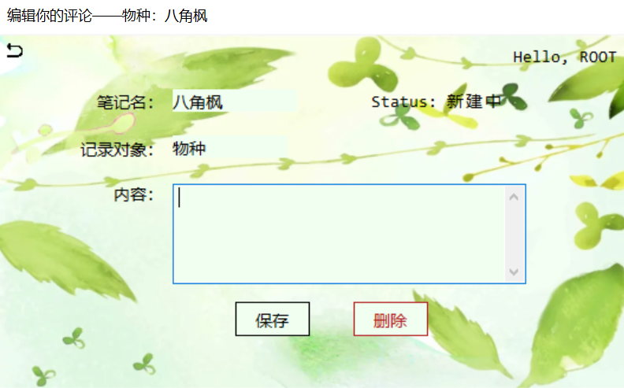

**(2) 功能**

增加、编辑、删除与科/物种相关的笔记

**(3) 代码**

同上（为同一窗体的不同打开模式）

1. 用户权限管理界面（限定ROOT用户）

**(1) 界面展示**

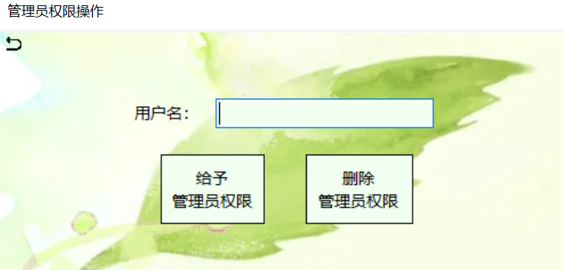

**(2) 功能**

给予特定用户管理员权限，使得其能够编辑或增加词条

**(3) 代码**

using System;

using System.Collections.Generic;

using System.ComponentModel;

using System.Data;

using System.Drawing;

using System.Linq;

using System.Text;

using System.Threading.Tasks;

using System.Windows.Forms;

using System.Data.SqlClient;

namespace PlantDB

{

public partial class AdminEdit : Form

{

SqlConnection conn = new SqlConnection

("DataBase=PlantInfo; Data Source=(local); Integrated Security = True;");

String usrname, usr_mode;

public AdminEdit(String mode, String usrname)

{

InitializeComponent();

this.usrname = usrname;

this.usr_mode = mode;

this.Show();

this.usrbox.Focus();

}

private void add_Click(object sender, EventArgs e)

{

String aim_usr = this.usrbox.Text.Trim();

if (!is_usrname_exist(aim_usr))

MessageBox.Show("该用户不存在！", "提示", MessageBoxButtons.OK, MessageBoxIcon.Error);

else if (aim_usr == "ROOT")

MessageBox.Show("不可对ROOT进行操作！", "提示", MessageBoxButtons.OK, MessageBoxIcon.Error);

else

{

update_accessibility('A');

MessageBox.Show("成功添加！", "提示", MessageBoxButtons.OK, MessageBoxIcon.Information);

}

this.usrbox.Text = "";

this.usrbox.Focus();

}

private void remove_Click(object sender, EventArgs e)

{

String aim_usr = this.usrbox.Text.Trim();

if (!is_usrname_exist(aim_usr))

MessageBox.Show("该用户不存在！", "提示", MessageBoxButtons.OK, MessageBoxIcon.Error);

else if(aim_usr == "ROOT")

MessageBox.Show("不可对ROOT进行操作！", "提示", MessageBoxButtons.OK, MessageBoxIcon.Error);

else

{

update_accessibility('C');

MessageBox.Show("成功移除！", "提示", MessageBoxButtons.OK, MessageBoxIcon.Information);

}

this.usrbox.Text = "";

this.usrbox.Focus();

}

private void update_accessibility(char mode) {

String aim_usr = this.usrbox.Text.Trim();

String sql = "UPDATE Users SET accessibility = '" + mode + "' WHERE usrname = '" + aim_usr + "';";

conn.Open();

SqlCommand cmd = new SqlCommand(sql, conn);

cmd.ExecuteNonQuery();

conn.Close();

}

private bool is_usrname_exist(String name)

{

String sql = "SELECT usrname FROM Users WHERE usrname = '" + name + "';";

SqlCommand cmd = new SqlCommand(sql, conn);

conn.Open();

SqlDataReader dr = cmd.ExecuteReader();

if (dr.HasRows)

{

conn.Close();

return true;

}

else

{

conn.Close();

return false;

}

}

private void back_Click(object sender, EventArgs e)

{

Form home = new Home(usr_mode, usrname);

this.Close();

}

}

}

五．系统测试

1. 登录功能测试

### **(1) 用户名不存在**

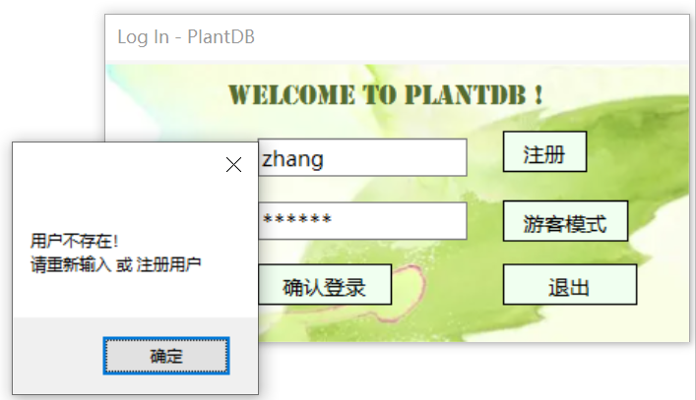

1. **密码错误**

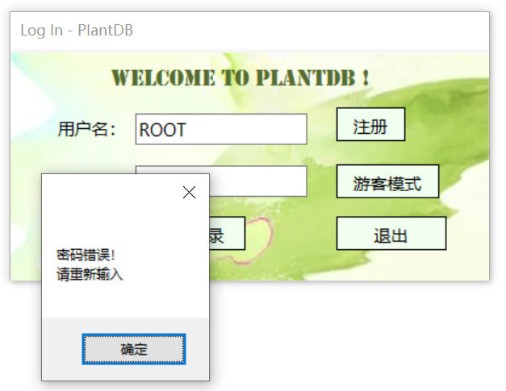

1. **正常登录**

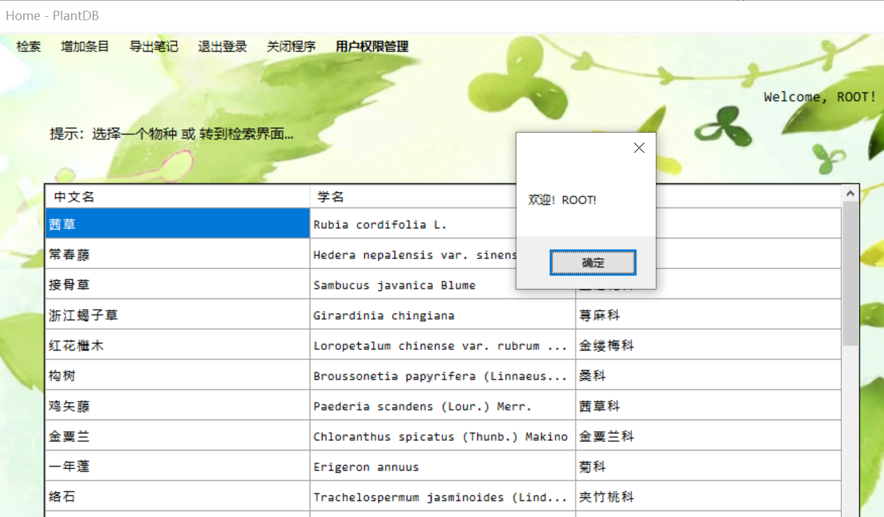

1. 注册
2. 用户名已存在

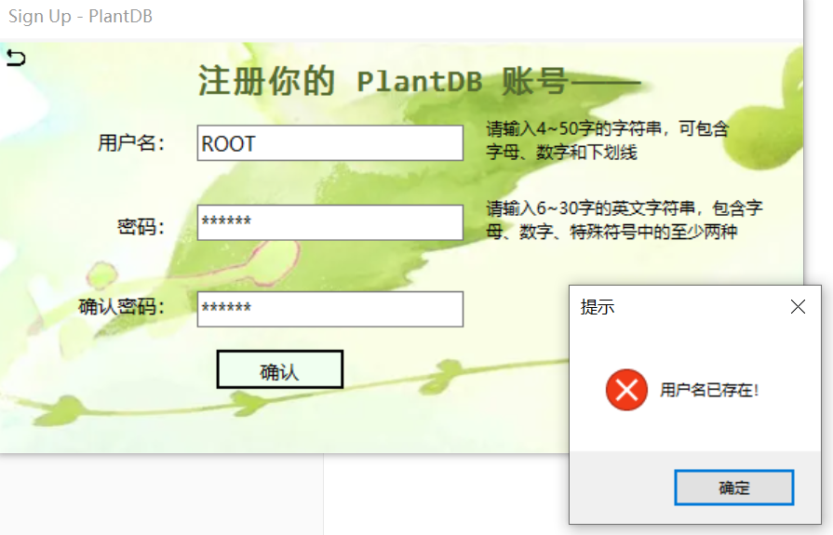

1. 用户名格式不符合要求

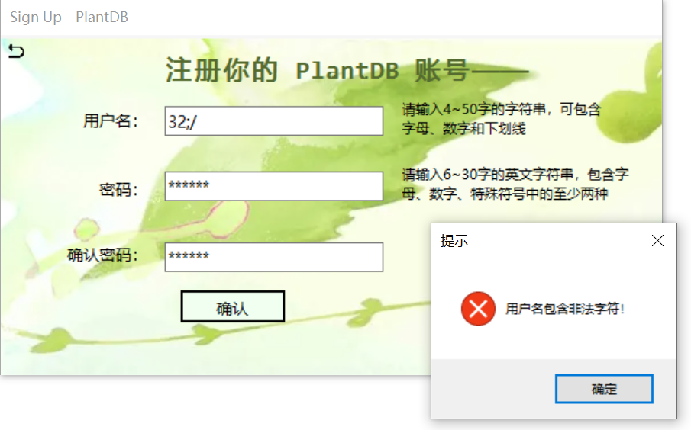

1. 密码不符合要求

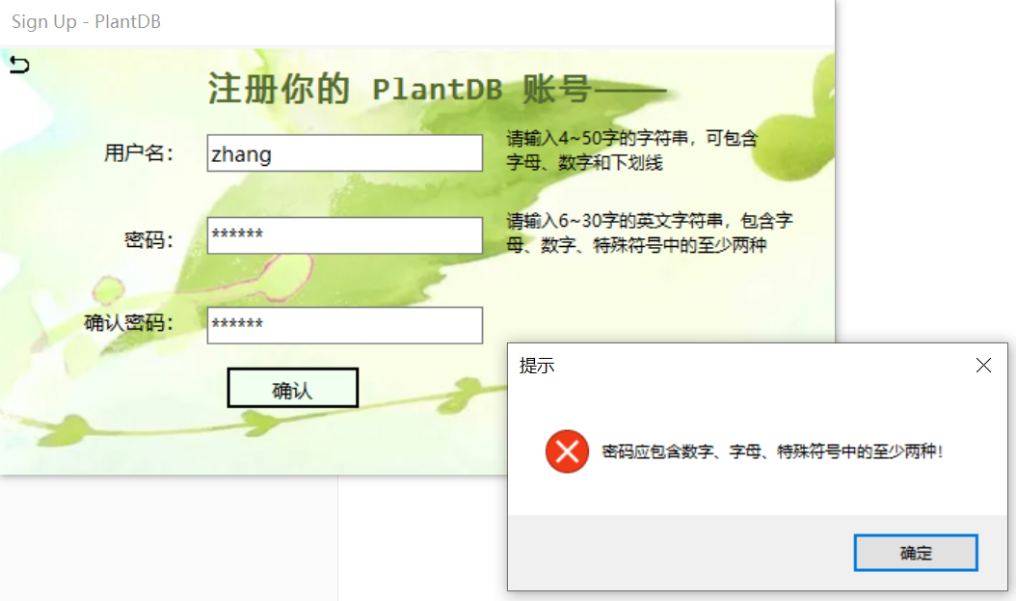

1. 两次输入的密码不一致

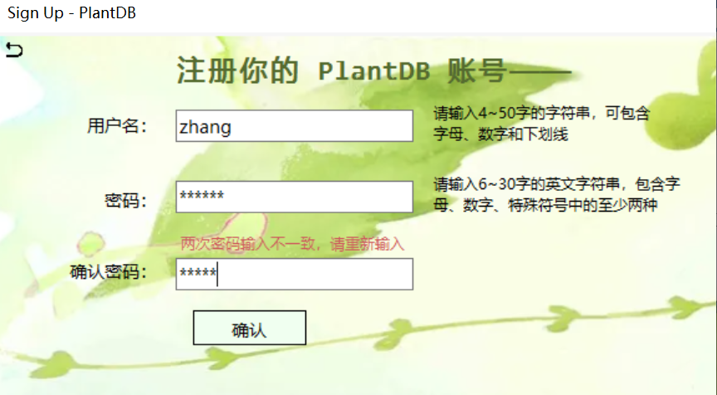

1. 成功注册

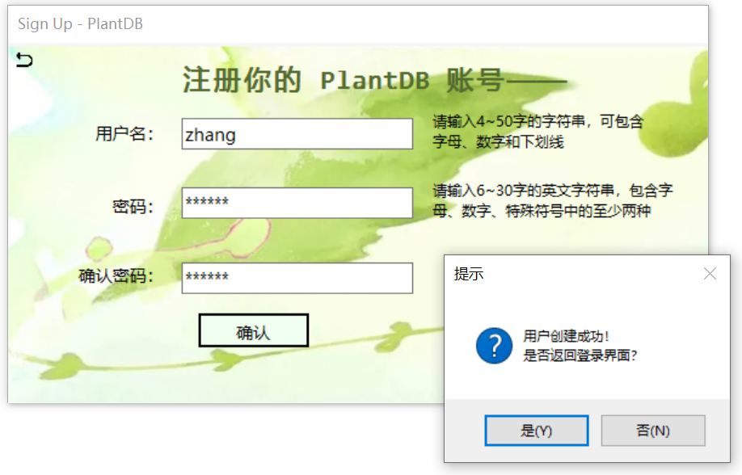

1. 用户主页（Home）
2. 导出笔记功能

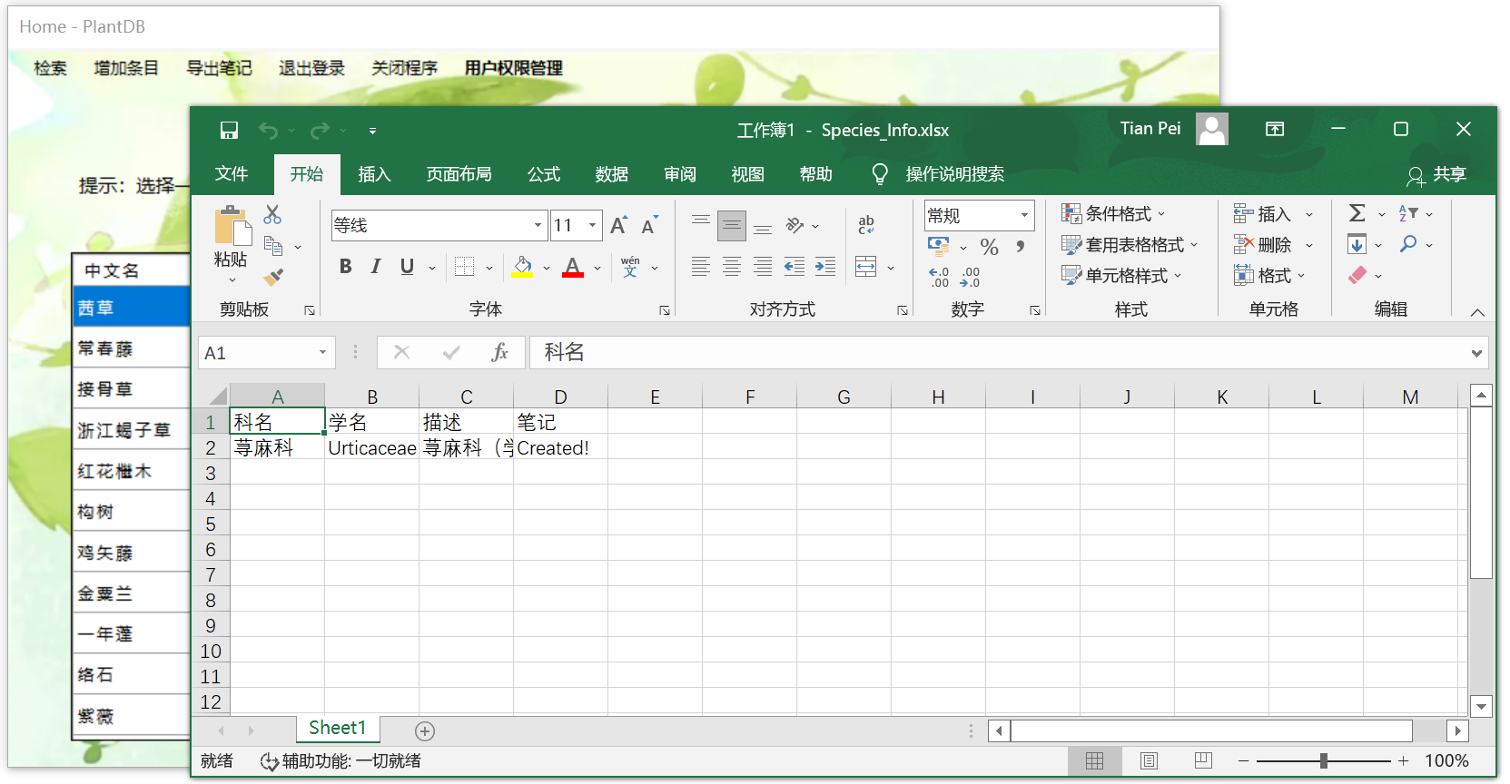

1. 增加条目功能

用户无管理权限时：

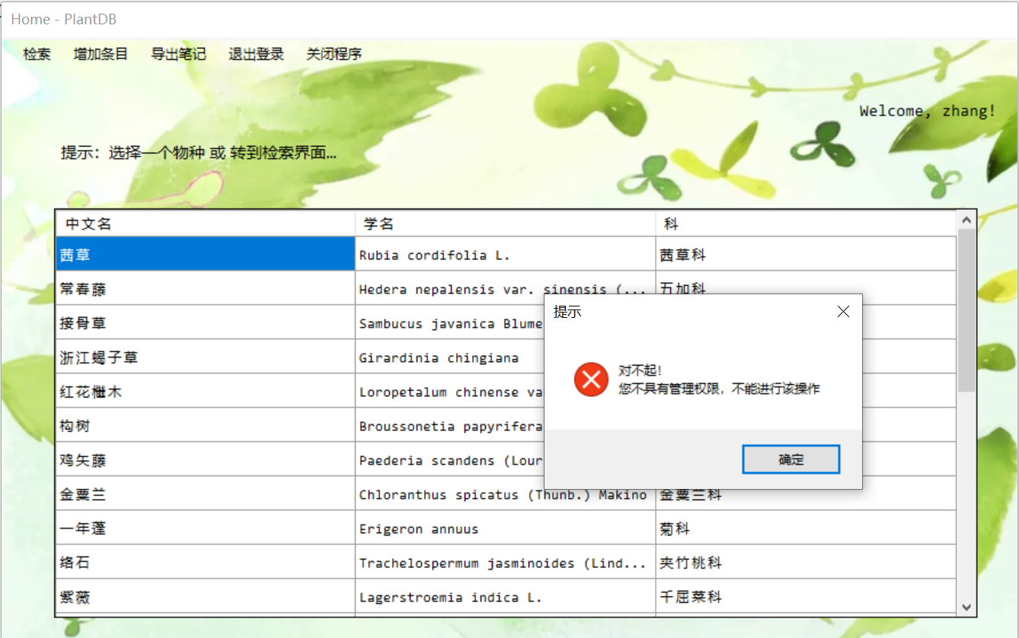

用户有管理权限时：

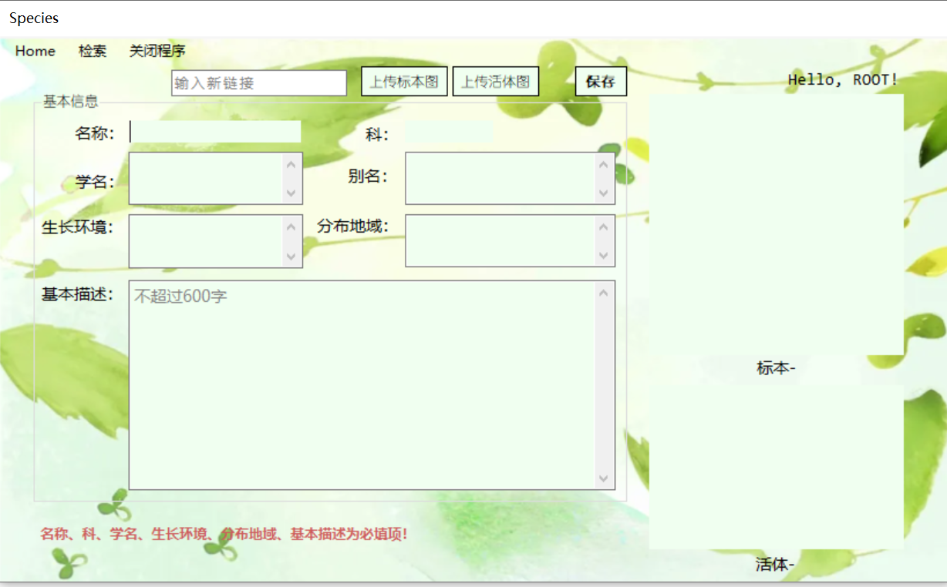

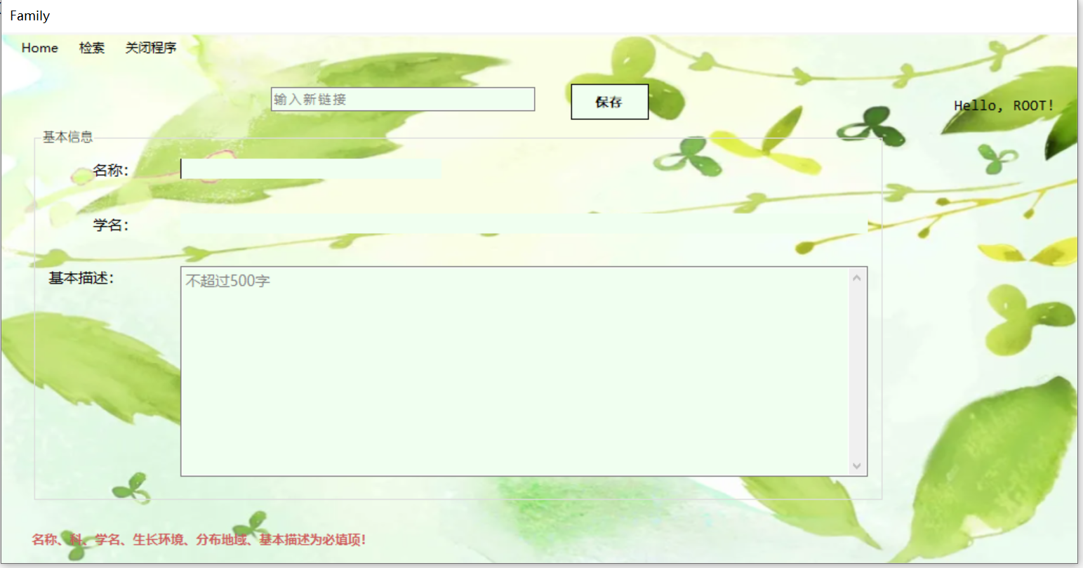

1. 退出登录

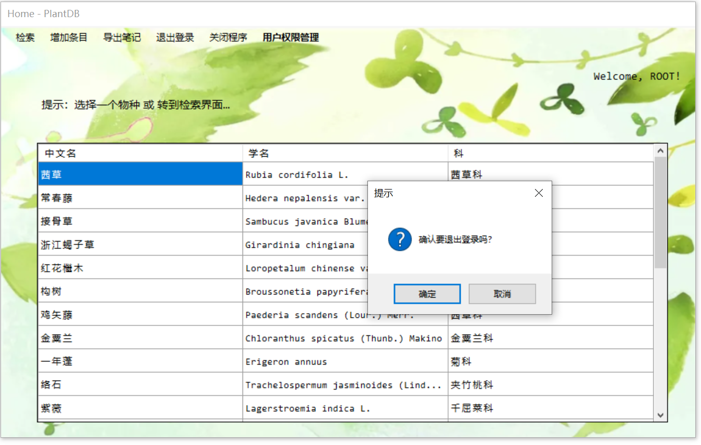

1. 检索
2. 中文名检索

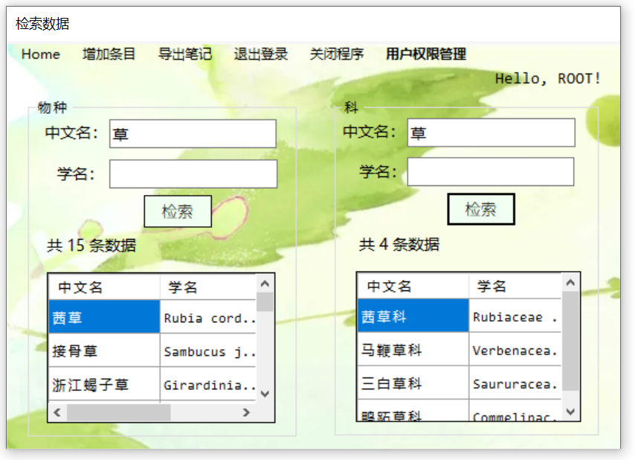

1. 学名检索

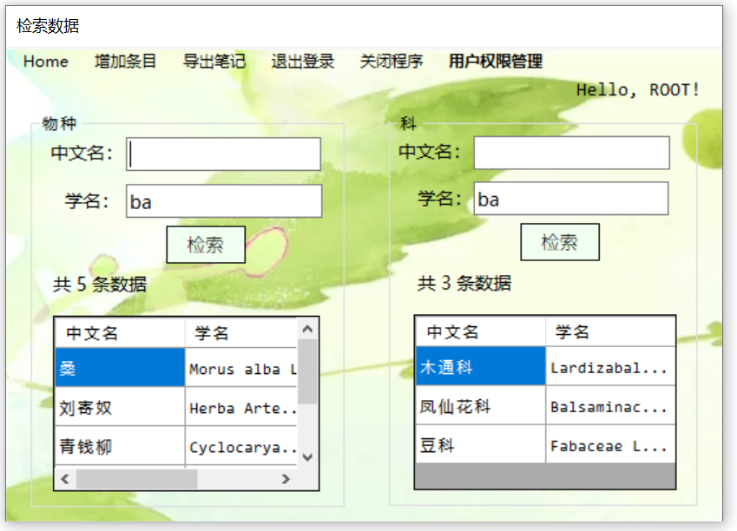

1. 中文名、学名联合检索

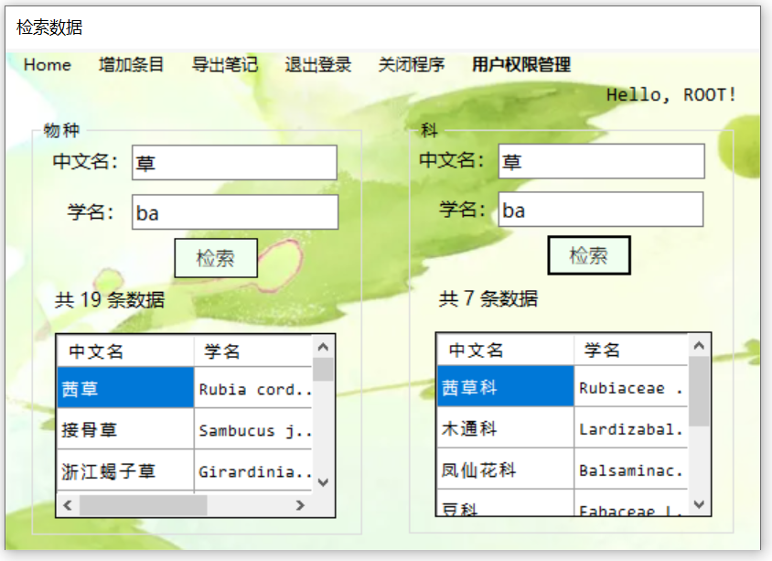

1. 检索失败

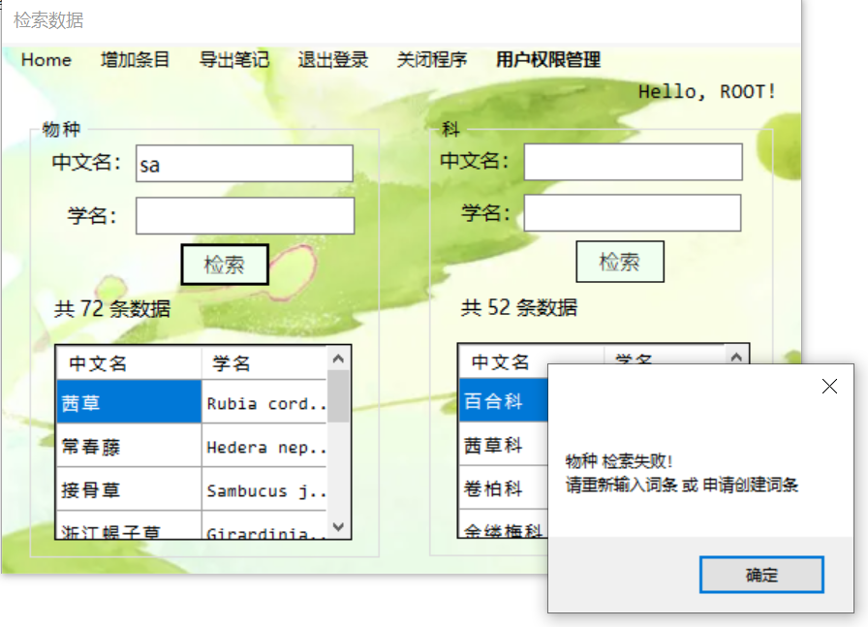

5. 物种信息编辑

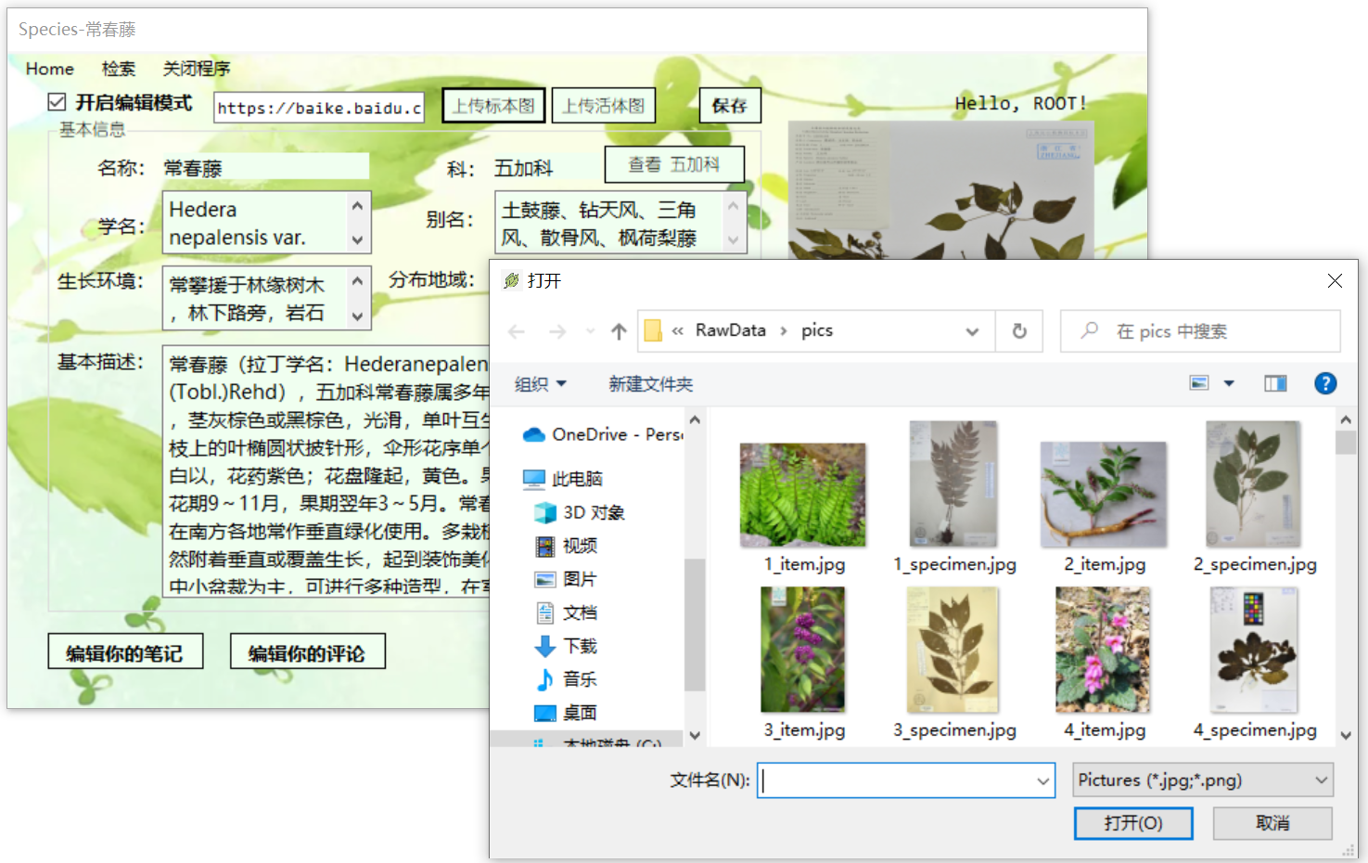

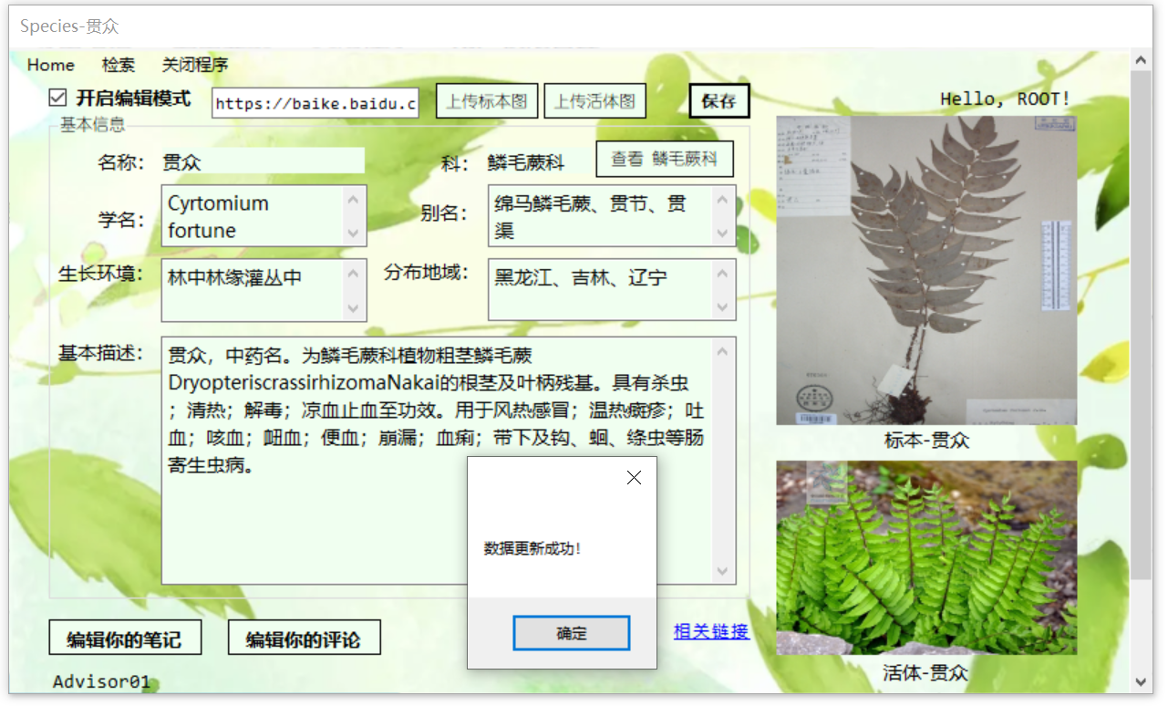

6. 科信息编辑

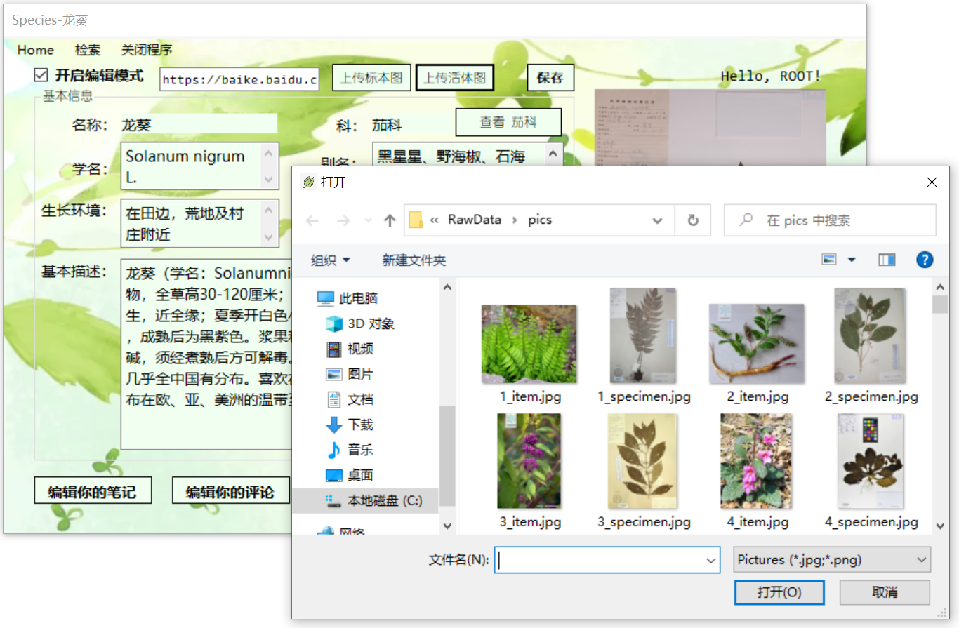

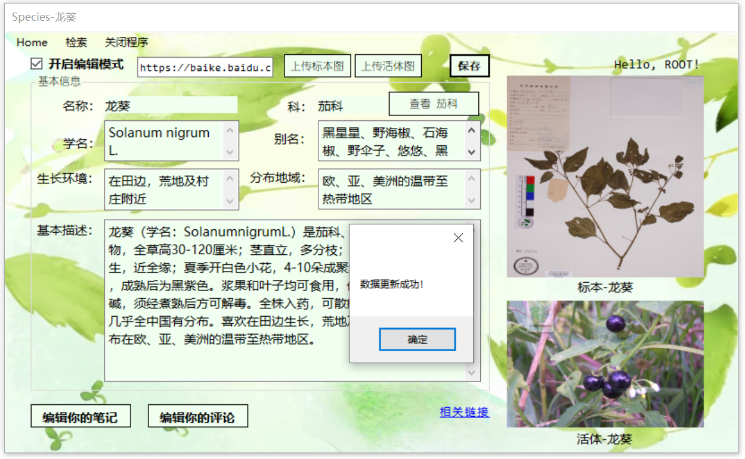

7. 物种/科笔记

### (1) 新建

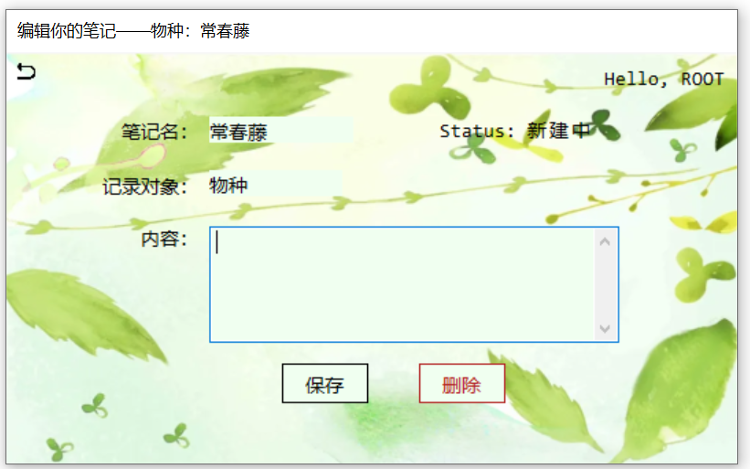

### (2) 编辑

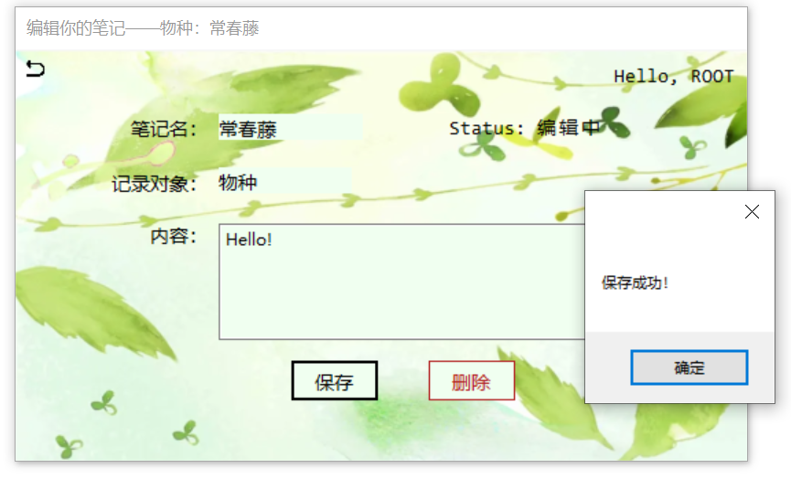

### (3) 删除

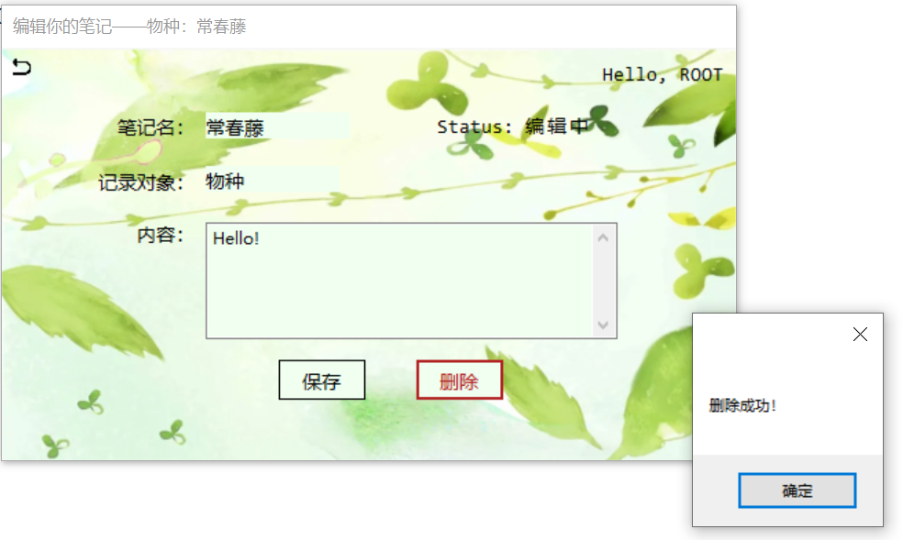

### (4) 游客登录

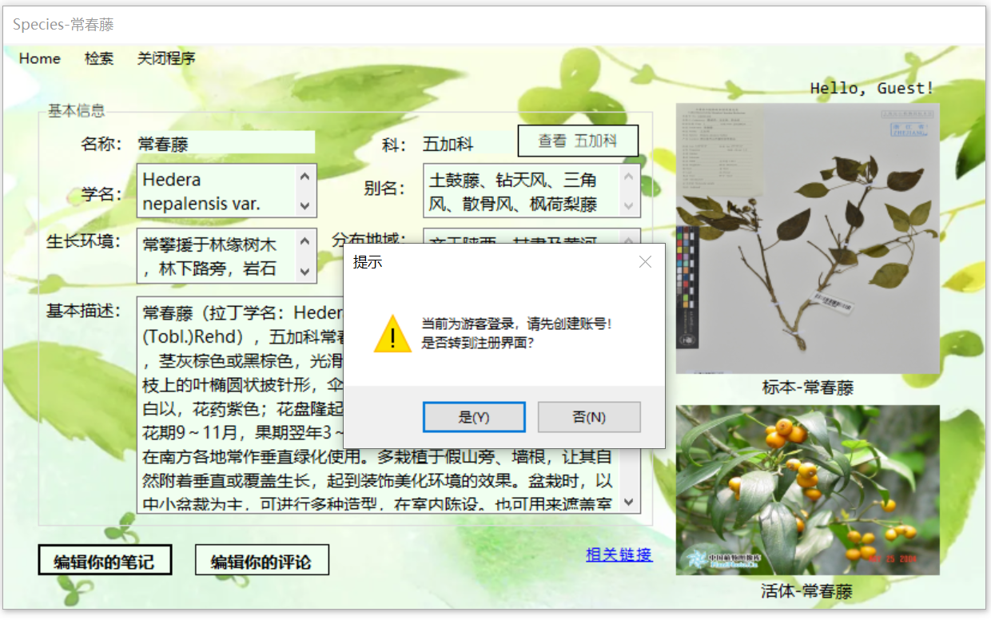

8. 物种/科评论

### (1) 新建

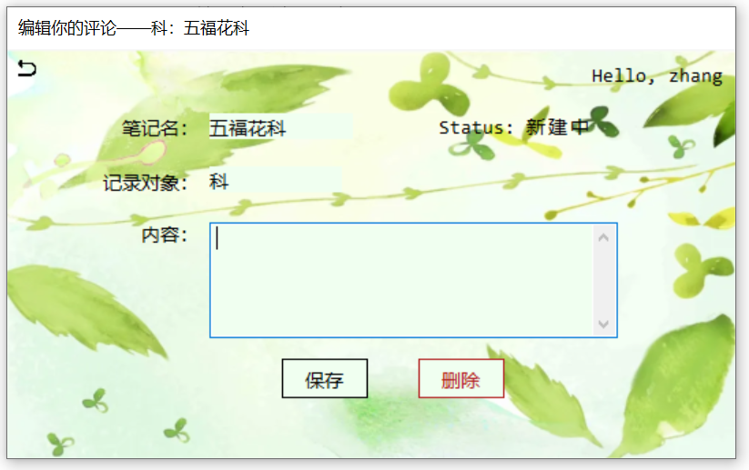

### (2) 编辑

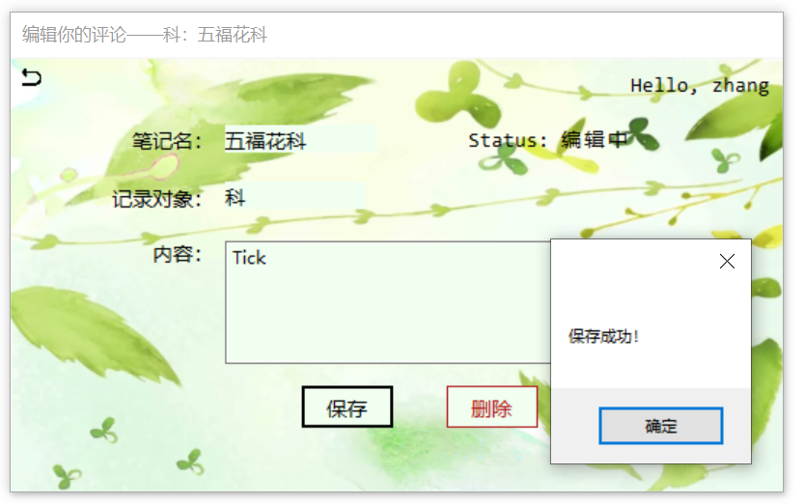

评论显示：

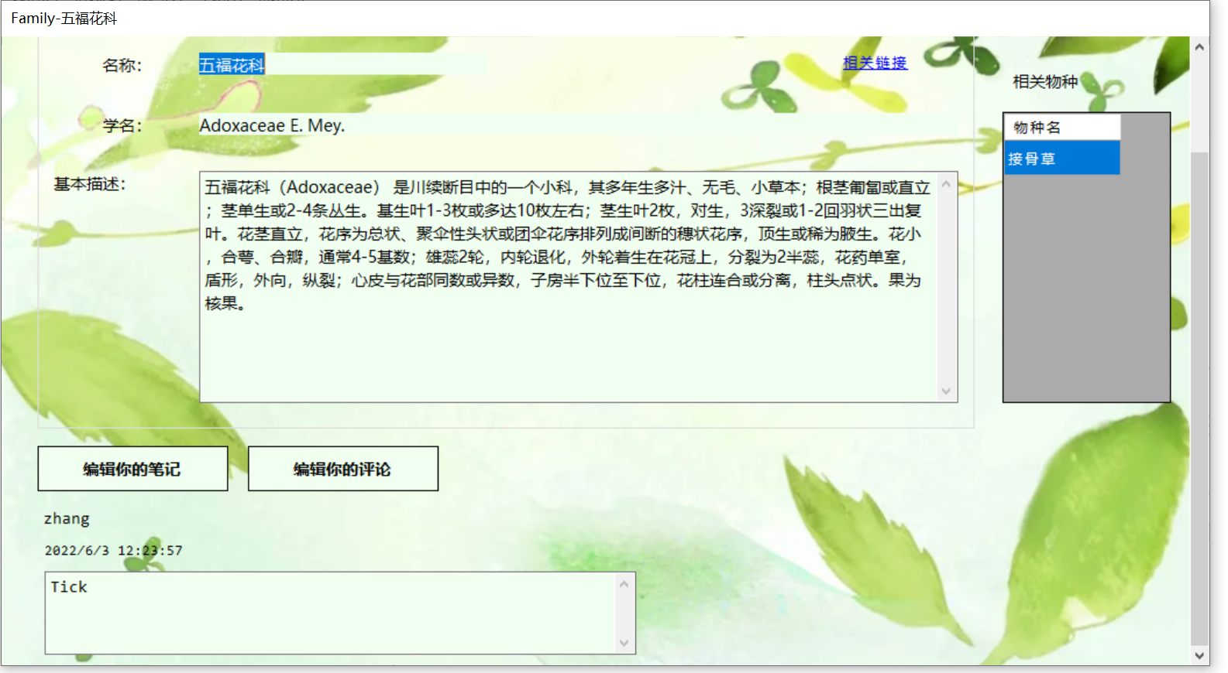

### (3) 删除

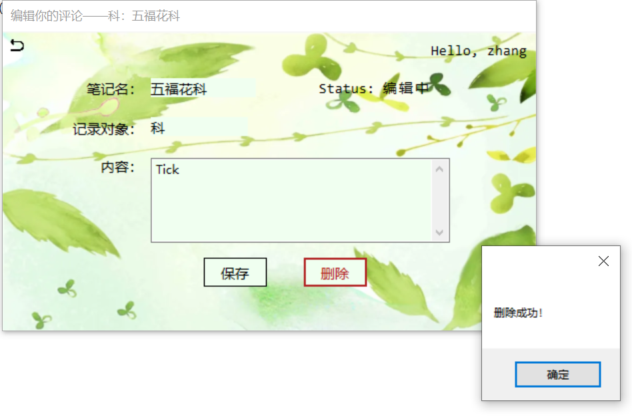

### (4) 游客登录

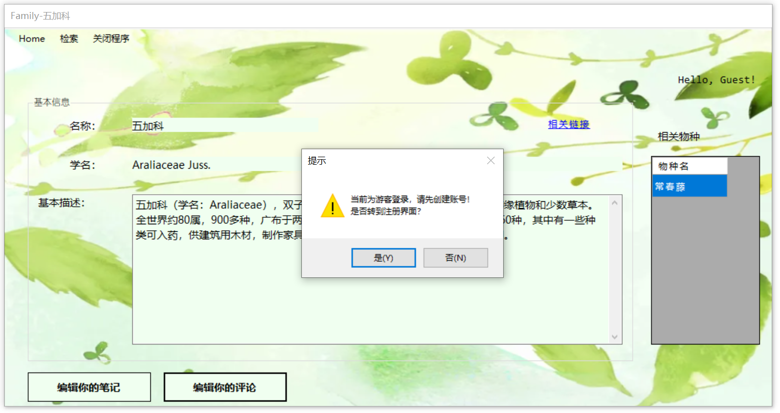

9. 用户权限管理界面（限定ROOT用户）

### (1) 新增管理员

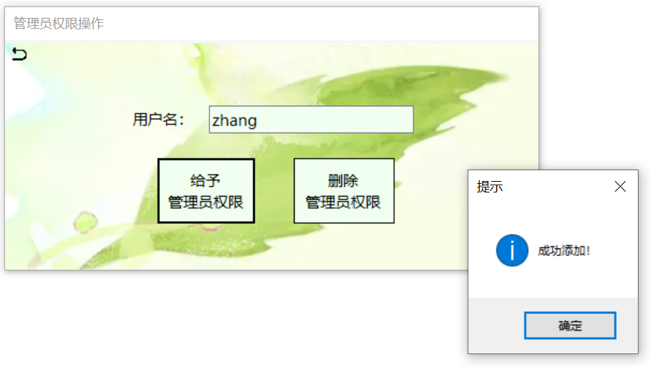

### (2) 删除管理员

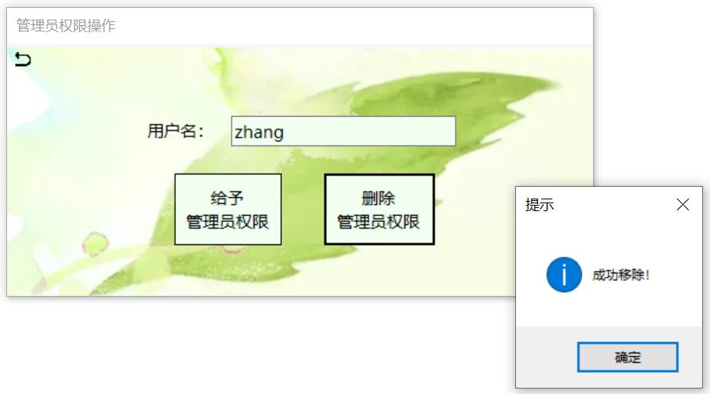

### (3) 用户不存在

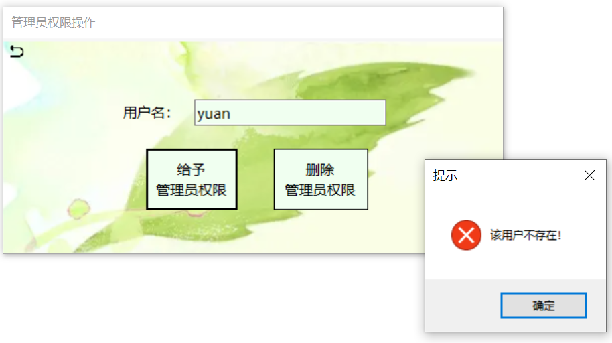

六．自我评述

通过该课程的学习，我掌握了SQL基本知识，SQL Servers数据库管理系统的使用方法，以及.NET基本编程技巧和通过ADO.NET访问SQL Server数据库的方法。另外，我还对T-SQL、存储过程、触发器等数据库知识有了初步了解。

通过学习、掌握、联系老师在课堂上传授的数据库设计知识，如范式设计、逻辑模式设计、概念模型设计等，我对于数据库中实体表对象和关系表对象的设计和建立有了较为深刻的认知。同时，通过案例学习和项目设计等课程环节，我也在实践中落实了这些概念，通过切实的操作使得自身对这些概念有了更为确切的掌握。

总之，通过这一课程的学习，我掌握了许多关于数据库设计和C#编程的知识，且通过最终项目设计，我更在实践中锻炼了自己的编程能力，收获颇丰。

七．课程学习体会与建议

在该课程的学习中，我除了通过老师的讲解吸收一系列的新知识外，通过实践项目落实了理论知识，锻炼了自己在事件中解决问题的能力。

我对课程中的各种实践环节和最终的项目设计印象颇深，在实际解决问题的过程中，我学会了灵活使用多种渠道解决问题，以达到最终的项目设计目标。在实际操作中遇到问题、解决问题是我在课程学习中的基本节奏，通过它，我对课程的理论知识和实践操作都有了深刻的认知。

如若条件允许，我建议该课程可以适当增加项目实践环节和项目分享环节，让学生在实践中落实知识的掌握，并通过相互交流进一步巩固知识，消灭盲区。